Protecting A Taonga Species Through Community Action

Programme Purpose and Objectives
The National Īnanga Spawning Programme represents a collaborative nationwide effort to identify, monitor, protect, and restore īnanga spawning habitat across Aotearoa New Zealand. Led by Mountains to Sea Conservation Trust, alongside regional and territorial authorities, community groups, and tangata whenua, this programme builds upon a rich history of īnanga conservation.

Programme Goals
- Re-establish a comprehensive national database of īnanga spawning sites to replace the original database that ceased maintenance around 2002.
- Standardise survey methodologies across all regions to ensure consistent, high-quality data collection.
- Provide accessible tools including modern survey apps and a centralised data hub for community groups and agencies.
- Build capability and capacity through training, support, and knowledge sharing.
- Inform conservation management and restoration priorities at local, regional, and national levels.
- Contribute to īnanga population recovery through coordinated nationwide monitoring and protection efforts.

Why Īnanga Matter

Cultural and Recreational Significance
Īnanga (Galaxias maculatus) are taonga species holding immense cultural, ecological, and recreational value. They form approximately 90% of New Zealand's iconic whitebait fishery and are deeply connected to the identity of many New Zealanders and the mahinga kai traditions of Māori. The knowledge of when and where īnanga spawn, and how to protect these spawning sites, is part of mātauranga Māori passed down through generations.

Ecological Importance
Īnanga play a crucial role in coastal and freshwater ecosystems. They transfer nutrients between the moana and our awa during their life cycle and provide kai for numerous native manu (birds), fish, and other wildlife. As a largely annual species with most individuals surviving only 1-2 years, the health of spawning sites directly determines the abundance of the next generation.

Conservation Status
Īnanga are currently classified as "Threatened – Nationally Vulnerable" in the New Zealand Threat Classification System. Spawning sites are the limiting factor in recruitment which significantly affects the size of the whitebait run and subsequent adult abundance. Their spawning sites face multiple threats including:
- Habitat loss and degradation from urban development and intensive land use
- Modification of riparian vegetation through clearing, mowing, and weed invasion
- Stock trampling and grazing of spawning vegetation
- Changes to tidal inundation patterns from flood control works
- Barriers to fish passage (culverts, floodgates, weirs)
- Predation of eggs by introduced species (rats & mice)
- Water quality degradation & sedimentation
- Climate change impacts on tidal patterns and water levels

Understanding Īnanga Ecology

The Remarkable Life Cycle
Īnanga have a unique diadromous life cycle, migrating between fresh and salt water:
Egg Stage: Eggs are laid in riparian vegetation during spring tides during autumn and winter months (spawning season varies regionally). Uniquely, īnanga eggs develop terrestrially, making them vulnerable to desiccation and predation. The tiny transparent spheres (approximately 1 mm diameter) are deposited amongst grass stems just above ground level, where they remain until the next spring tide cycle triggers hatching.

Larval Stage (3-6 months): Newly hatched larvae (approximately 7 mm long) are carried out to sea with the outgoing tide, where they spend winter feeding on marine plankton and growing rapidly.

Whitebait Stage (spring migration): Fish return to freshwater as translucent juveniles (whitebait) predominantly during spring, typically 40-50 mm in length. This is the stage targeted by the whitebait fishery.

Adult Stage: Īnanga reach sexual maturity at approximately one year of age and feed primarily on aquatic and terrestrial invertebrates. Unlike other galaxiids, adults are diurnal and swim in shoals, making them relatively easy to observe.

Extraordinary Spawning Behaviour
Īnanga spawning is precisely timed to spring tides occurring around the new and full moon phases. Peak spawning typically occurs for 2-3 days after the new or full moon when spring tides are at their highest. This timing ensures:
- Maximum inundation of riparian vegetation
- Eggs are laid above normal high tide levels
- Eggs remain out of water during development
- The next spring tide cycle inundates eggs to trigger hatching

As the tide rises, shoals of adult īnanga congregate at the interface of where fresh water (waitī) meets salt water (waitā), at the apex of the saltwater wedge, the area we call the “Love Zone”. They push into flooded riparian vegetation at the very edge of the water, as high as the tide reaches. Females release up to several thousand eggs amongst the stems of the inundated streamside vegetation while males release milt (sperm) to fertilise them. As the tide recedes, eggs remain attached to the dense stems and root mats of vegetation just above ground level. Spawning is energetically costly, and many fish die after spawning, though some survive to spawn again in subsequent years.

Critical Habitat Requirements
Spawning Sites: Īnanga show strong preferences for specific spawning habitats, particularly in upper estuarine reaches where tidal influence meets freshwater. Sites must be inundated by spring tides but remain above normal high tide levels. Dense, fine-stemmed grasses and rushes are essential; providing egg attachment substrate, shade to moderate temperature, humidity to prevent desiccation, and protection from predators.

Both native species (wīwī, oioi, raupo, harakeke, toetoe) and exotic species (tall fescue, kikuyu) can provide suitable spawning habitat, though native vegetation is preferred for restoration efforts.

Adult Habitat: Adult īnanga inhabit coastal rivers and streams, estuaries, lagoons, lowland lakes and wetlands, favouring slow-moving or still water areas. Unlike other migratory galaxiids, īnanga are poor climbers and cannot negotiate waterfalls or rapid flows, limiting their distribution to lowland coastal areas unless river gradients are very gentle. In many cases īnanga migration is interrupted by modern infrastructure like culverts and weirs.

The Role of Surveys and Community Involvement

Why Standardised Surveys Matter
Since the original national database ceased maintenance around 2002, valuable spawning site records have become dispersed across many agencies in different formats. This makes it difficult to understand the national picture of īnanga spawning habitat status and trends. Standardised surveys using proven field techniques and modern data collection tools enable:
- Accurate identification and mapping of spawning sites.
- Consistent monitoring of spawning activity.
- Assessment of habitat quality and threatening processes.
- Informed decision-making for conservation management.
- Coordinated restoration efforts at sites of highest priority.

Community as Kaitiaki
Protecting and restoring īnanga spawning habitat requires action at the local level. Community groups, landowners, kura, iwi, hapū, and local authorities are the kaitiaki best positioned to identify, monitor, and protect spawning sites within their rohe. This programme empowers communities with the mātauranga, tools, and support needed to make a real difference for īnanga conservation.

When communities work together with agencies and researchers in a te tiriti-based partnership, meaningful conservation outcomes can be achieved that benefit both īnanga and the broader mauri of our wai. Every survey contributes to a growing understanding of spawning sites across Aotearoa, helping to:
- Identify priority sites for protection.
- Inform regional and national conservation planning.
- Support research into īnanga ecology and spawning habitat.
- Contribute to mahinga kai restoration efforts.
- Enable tracking of long-term trends.
- Support mana whenua in their kaitiaki role.

Development and Role of the NĪSP Apps and Hub
MTSCT has developed mobile applications for systematic saltwater wedge surveys, spawning site identification, habitat assessments, egg quantification, and restoration tracking. Survey123 forms capture standardised field data including salinity measurements, GPS coordinates, vegetation characteristics, and egg quantification. FieldMaps enable offline data collection with automated synchronisation. The integrated Īnanga Spawning Hub provides real-time data visualisation through interactive dashboards and mapping interfaces, supporting evidence-based conservation decisions.
The hub displays: Love Zones, Spawning sites, Habitat Assessments, Planting sites, Fence installation, Fish Passage barriers, and the orange polygon representing the Proposed Īnanga Spawning Protection Area.

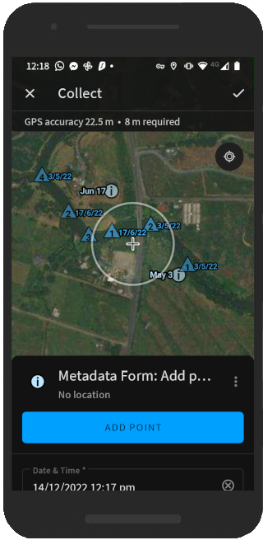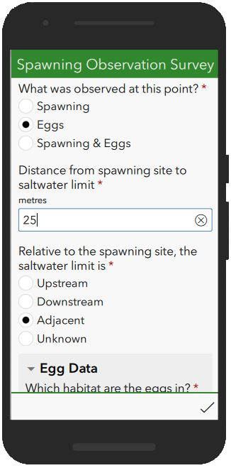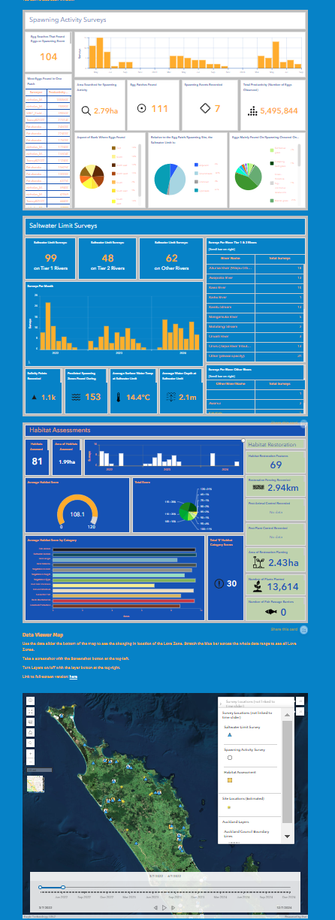

These resources are backed by a comprehensive NĪSP Manual and Quick Guides to using the apps (Apple and Android versions available)

Looking Forward
The National Īnanga Spawning Programme represents a critical step toward securing the future of this taonga species. By combining modern technology with traditional knowledge, standardised methodology with local expertise, and scientific rigour with community passion, we are building a comprehensive national picture of īnanga spawning habitat.

The hauora of our īnanga populations reflects the mauri of our estuaries, streams, and coastal environments. Through this programme, we strengthen partnerships between community groups, iwi, regional councils, and central government agencies, all working together towards the common goal of īnanga conservation and the continued access to mahinga kai for future generations.

Get Involved
The programme provides comprehensive training, modern survey tools, and ongoing support for community groups, landowners, and agencies committed to īnanga conservation. Together, we can protect these remarkable fish and the unique spawning sites they depend upon.

For more information: Contact Nicholas Naysmith at Mountains to Sea Conservation Trust
nicholas@mountainstosea.org.nz

MTSCT and the National Īnanga Spawning Programme acknowledges the mana whenua and kaitiaki of the places where īnanga spawn, and recognises the deep whakapapa connection that Māori have with these awa, repo, and coastal environments and their inhabitants.

Notes:

Notes:

Notes:

