

N.Ī.S.P. Manual

Table of Contents
1. Welcome and Introduction 2
Acknowledgements 2
Course Objectives 2
2. About the National Īnanga Spawning Programme 3
Programme Overview 3
Why Īnanga Spawning Sites Matter 4
3. Īnanga Ecology and Biology 5
Species Description 5
Life Cycle 6
Spawning Behaviour 9
Habitat Requirements 10
Distribution 11
4. Survey Techniques and Methodology 12
Pre-Survey Planning 12
Saltwater Wedge Surveys 13
Calibrating your Salinity Meter 14
Finding and Assessing Spawning Habitats 14
Habitat Assessment Survey 17
Quantifying Eggs 18
Installing Artificial Spawning Habitat 21
5. Using the Survey Apps 25
Getting Started 25
6. The Data Hub - Access and Navigation 26
Accessing the Hub 26
7. Tips and Tricks for Effective Surveying 27
8. Restoration Planning and Best Practices 31
9. Predator Control Strategies 41
10. Health and Safety Considerations 45
11. Resources and Further Reading 50
12. Contact Information and Support 54
Appendices 58

1. Welcome and Introduction
Nau mai, haere mai
Welcome to the National Īnanga Spawning Programme manual. We're delighted you've chosen to join us in this important mahi of protecting and restoring īnanga spawning habitat across Aotearoa New Zealand.
Īnanga/Īnaka (Galaxias maculatus) are a taonga species that hold significant cultural, ecological, and recreational values. They are the most widespread of our native galaxiids and form a crucial part of the whitebait catch (approximately 90%). However, their spawning sites are increasingly threatened by habitat loss through changes in land use, degradation, and predation. This programme represents a nationwide effort to identify, monitor, and protect these critical spawning areas.
During the course, you will gain the knowledge and practical skills needed to:
- Identify and assess potential īnanga spawning sites.
- Conduct standardised surveys using proven field techniques.
- Use our purpose-built survey apps and data hub.
- Contribute valuable data to a national monitoring network.
- Develop and implement effective restoration and predator control strategies.
This training will equip you to become active kaitiaki of īnanga spawning sites in your local area, joining a growing community of dedicated volunteers, community groups, iwi, hapū, councils, and agencies working together to secure the future of this species.

Acknowledgements
We acknowledge the mana whenua and kaitiaki of the places where īnanga spawn, and recognise the deep whakapapa connection that Māori have with these awa, repo, and coastal environments and their inhabitants. The hauora (health and wellbeing) of our īnanga populations reflects the mauri of our estuaries, streams, and coastal environments. This programme is strengthened by the partnerships between iwi, hapū, community groups, regional councils, and central government agencies, all working together towards the common goal of īnanga conservation and the continued access to mahinga kai.

Course Objectives
By the end of this training delivery programme, participants will be able to:
- Understand the basics of īnanga ecology, life cycle, and spawning behaviour.
- Identify suitable īnanga spawning habitat and recognise spawning sites.
- Conduct systematic spawning site surveys using standardised protocols.
- Confidently use the Field Maps and Survey123 apps for field data collection.
- Access and navigate the National Īnanga Spawning Programme Database Hub.
- Apply tips and techniques for effective surveying in various conditions.
- Develop site-specific restoration plans for degraded spawning habitat.
- Implement appropriate predator control measures at spawning sites.
- Contribute to the national effort to protect and restore īnanga populations.
- Connect with a network of practitioners and share knowledge and experiences.

2. About the National Īnanga Spawning Programme

Programme Overview
The National Īnanga Spawning Programme builds upon a rich history of īnanga conservation in Aotearoa. In 1987, the Department of Conservation commissioned nationwide field surveys to identify and protect īnanga spawning sites, with data collated into a database that was eventually administered by the National Institute of Water and Atmospheric Research (NIWA; now part of Earth Sciences NZ). This original database remained functional until ~2002 when maintenance and collation of records came to an end.
Since that time, many researchers, organisations, community groups, hapū/iwi, and councils have continued to search for and monitor īnanga spawning sites. However, these valuable records became dispersed across many agencies in different formats, making it difficult to understand the national picture of īnanga spawning habitat status and trends.
The current National Īnanga Spawning Programme represents a collaborative effort to re-establish and modernise the national database. Led by Mountains to Sea Conservation Trust, alongside regional authorities, community groups, and tangata whenua this programme has developed new survey methodologies, modern data collection tools, and a centralised data hub to support nationwide monitoring and conservation efforts.
Programme Goals:
- Re-establish a comprehensive national database of īnanga spawning sites.
- Standardise survey methodologies across all regions.
- Provide accessible tools for community groups and agencies to conduct surveys.
- Build capability and capacity through training and support.
- Inform conservation management and restoration priorities.
- Contribute to the recovery of īnanga populations nationwide.

Why Īnanga Spawning Sites Matter
Īnanga are a taonga species that hold immense cultural, ecological, and recreational significance. They form the bulk (approximately 90%) of New Zealand's iconic whitebait fishery and are deeply connected to the identity of many New Zealanders and mahinga kai traditions of Māori. The knowledge of when and where īnanga spawn, and how to protect these spawning sites, is part of mātauranga Māori that has been passed down through generations.
Īnanga play a crucial role in coastal and freshwater ecosystems. They transfer nutrients between the moana (ocean) and our awa (rivers) during their life cycle, and provide kai for numerous native manu (birds), fish (ika), and other wildlife. As a largely annual species with a relatively short lifespan (most survive only 1-2 years), the hauora (health and wellbeing) of spawning sites directly determines the abundance of the next generation.
Īnanga are currently classified as "Threatened – Nationally Vulnerable" in the New Zealand Threat Classification System. Their spawning sites face multiple threats:
- Habitat loss and degradation from urban development and intensive land use.
- Modification of riparian vegetation through clearing, mowing, and weed invasion.
- Stock trampling and grazing of spawning vegetation.
- Changes to tidal inundation patterns from flood control works.
- Barriers to fish passage (culverts, floodgates, weirs etc).
- Predation of eggs by introduced species (rats & mice).
- Water quality degradation affecting the mauri of our awa.
- Climate change impacts on tidal patterns and water levels.
“Protecting and restoring īnanga spawning habitat requires action at the local level.”
Protecting and restoring īnanga spawning habitat requires action at the local level. Community groups, landowners, kura, iwi, and local authorities are the kaitiaki best positioned to identify, monitor, and protect spawning sites in their rohe. This programme empowers communities with the mātauranga, tools, and support needed to make a real difference for īnanga conservation. When communities work together with agencies and researchers in a te tiriti-based partnership, we can achieve meaningful conservation outcomes that benefit both īnanga and the broader mauri of our wai.

3. Īnanga Ecology and Biology

Species Description
Scientific name: Galaxias maculatus (Jenyns, 1842)
Māori name: Īnanga/īnaka
Common names: Inanga, common galaxiid, whitebait (juvenile stage)
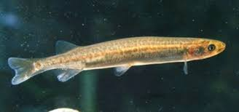
Image 1: Adult īnanga. Notice the olive, mottled skin, forked tail, and the origin of the dorsal fin directly above the anal fin. Photo by Stephen Moore.
Physical Description: Īnanga are the smallest of New Zealand's five migratory galaxiid species. Adults typically reach 80-100mm in length, though the longest recorded individual was 190mm. They are slender, streamlined fish with several distinctive features that make them relatively easy to identify:
- Colouration: Speckled olive to brown backs with a mottled, leopard-like pattern of dark spots.
- Belly: Distinctive silvery-white undersides.
- Tail: Slightly forked tail (unlike other galaxiids).
- Scales: No scales (like all galaxiids).
- Eyes: Iridescent silver eyes.
- Juveniles: Young īnanga (whitebait) have characteristic black mouths and line of dots along their flanks.
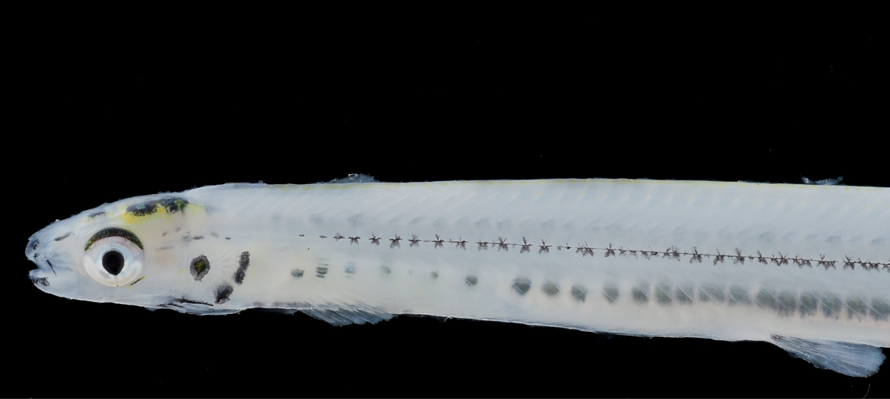
Image 2: Juvenile īnanga. Note the characteristic black mouths and line of dots along their flanks. Photo by Dr. Emily Roberts.
Īnanga are the only migratory galaxiid species that swim in shoals as adults. This schooling behaviour, combined with their silvery bellies and forked tails, helps distinguish them from other native fish species. They can sometimes be confused with smelt, but smelt have scales and an adipose fin, which īnanga lack.
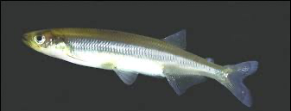
Image 3: Common smelt has scales, an adipose fin, and the origin of the dorsal fin is forward of the anal fin, distinguishing them from īnanga. Photo by R. M. McDowall.

Life Cycle
Īnanga have a diadromous lifecycle, meaning they migrate between fresh and salt water. More specifically they have an amphidromous lifecycle that is characterised by reproduction in fresh water, the newly hatched larvae are transported out to sea, followed by a period of feeding and growing, then a return to fresh water as juveniles (whitebait), then another period of feeding and growing in fresh water and gaining sexual maturity, followed by a reproductive event.
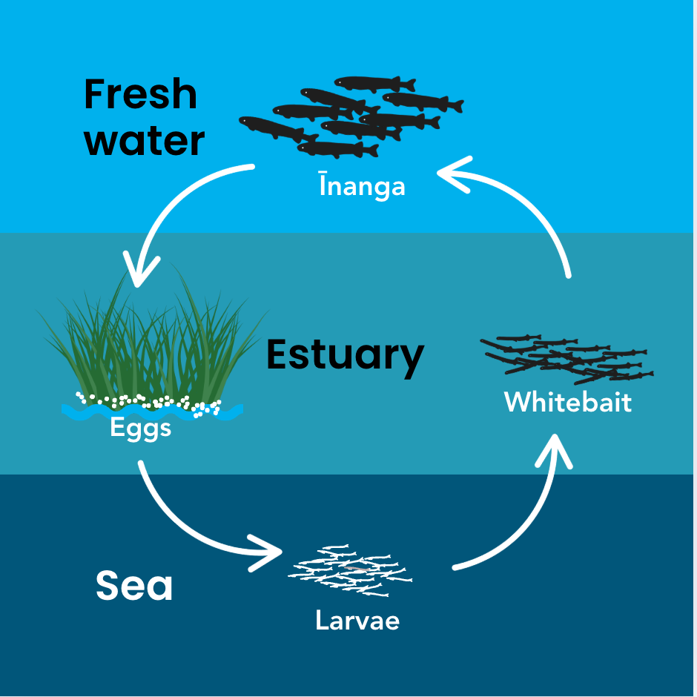
Figure 1: Īnanga spend parts of their lifecycle in both freshwater and marine environments and spawn in streamside vegetation. Image by MTSCT.

Egg Stage (approximately 28 days):
- Eggs laid in riparian vegetation during spring tides (March to August, but vary around the country. For instance eggs have been found from February to October in Northland. In Southland the spawning season runs through February and March.
- Eggs are approximately 1 mm in diameter, appearing as tiny transparent spheres.
- Approximately 5-10 days after spawning, black eyespots become visible inside the eggs.
- Eggs develop terrestrially, in humid air amongst riparian vegetation, not under water.
- Require protection from temperature extremes and desiccation (drying out).
- Hatch when inundated by the next spring tide cycle.
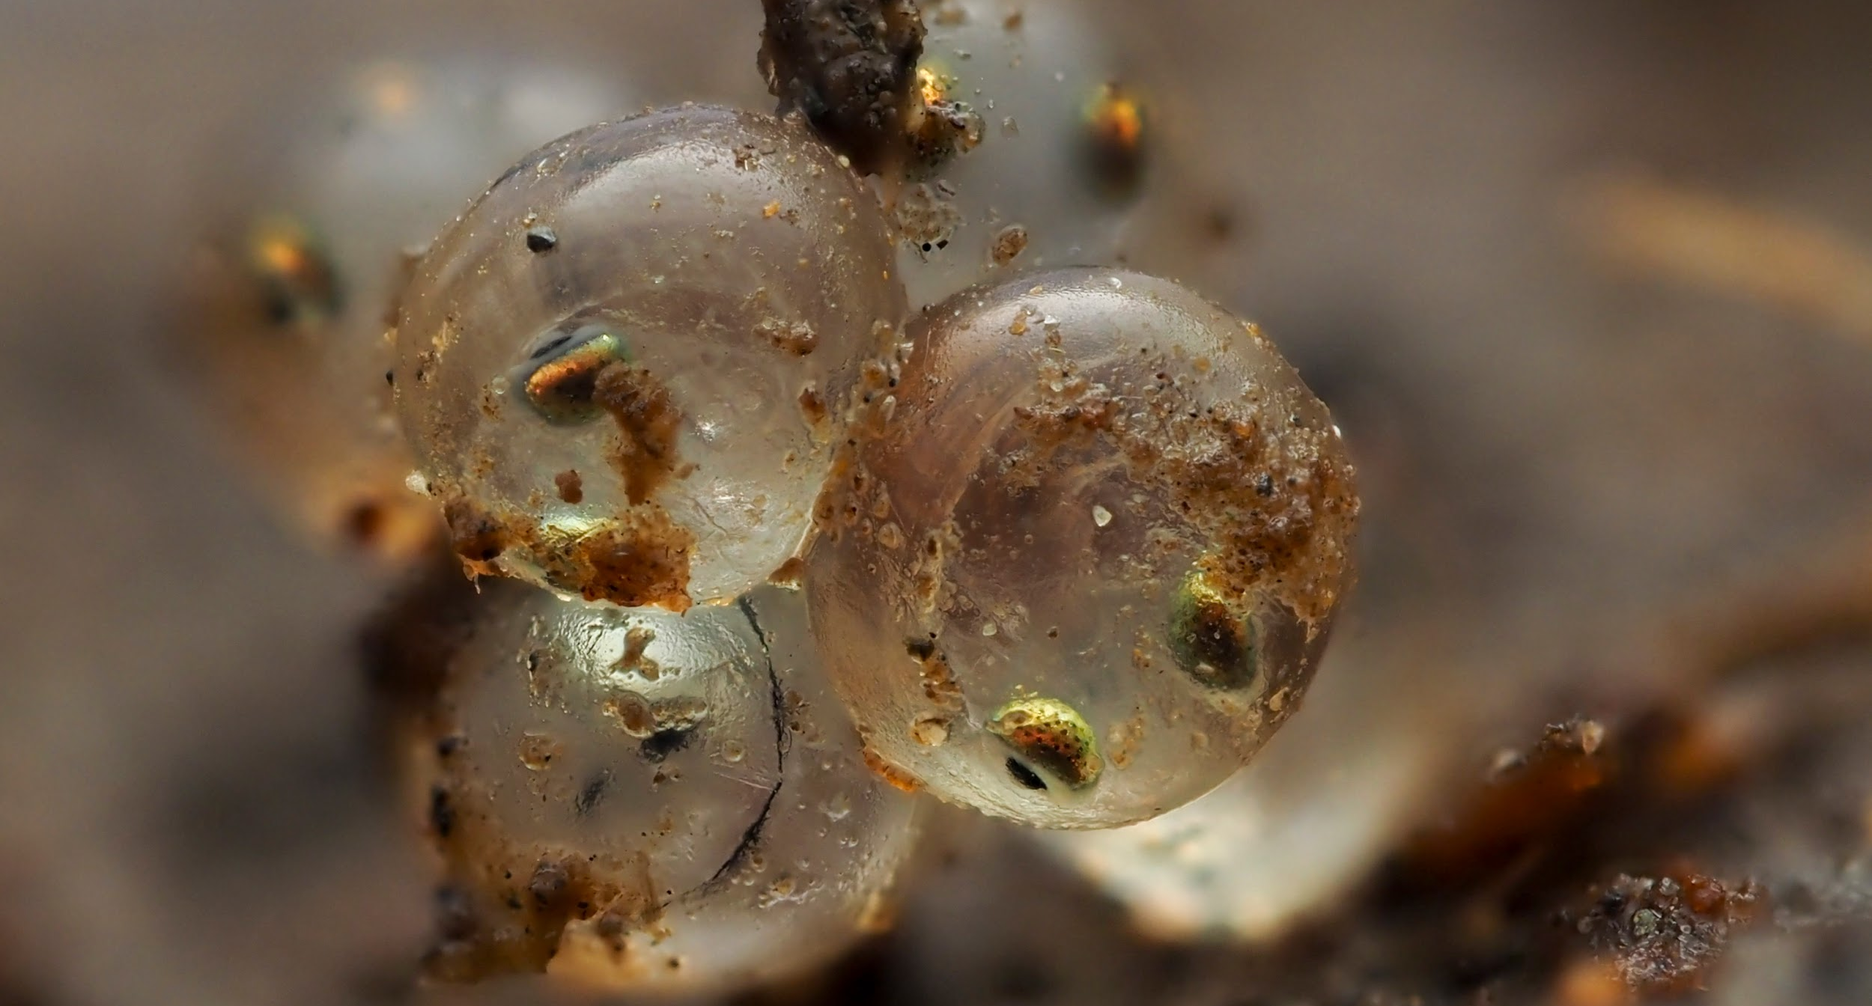
Image 4: Īnanga eggs. After about one week, black eyespots become visible inside the eggs. Helps to differentiate from slug and snail eggs that are frequently found in the same riparian vegetation. Photo by Dr. Emily Roberts.
Larval Stage (first 3-6 months):
- Newly hatched larvae are approximately 7 mm long.
- Carried out to sea with the outgoing tide and river currents.
- Spend winter at sea (approximately 3-6 months).
- Feed on marine plankton and grow rapidly.
- This marine phase is obligatory for most populations, but there are lacustrine (lake) populations.
Whitebait Stage (spring migration):
- Return to freshwater as translucent juveniles in mixed schools with other whitebait species during spring.
- Typically 40-50 mm in length during migration.
- Travel upstream in large runs, particularly during periods of low flow.
- This is the stage targeted by the whitebait fishery.
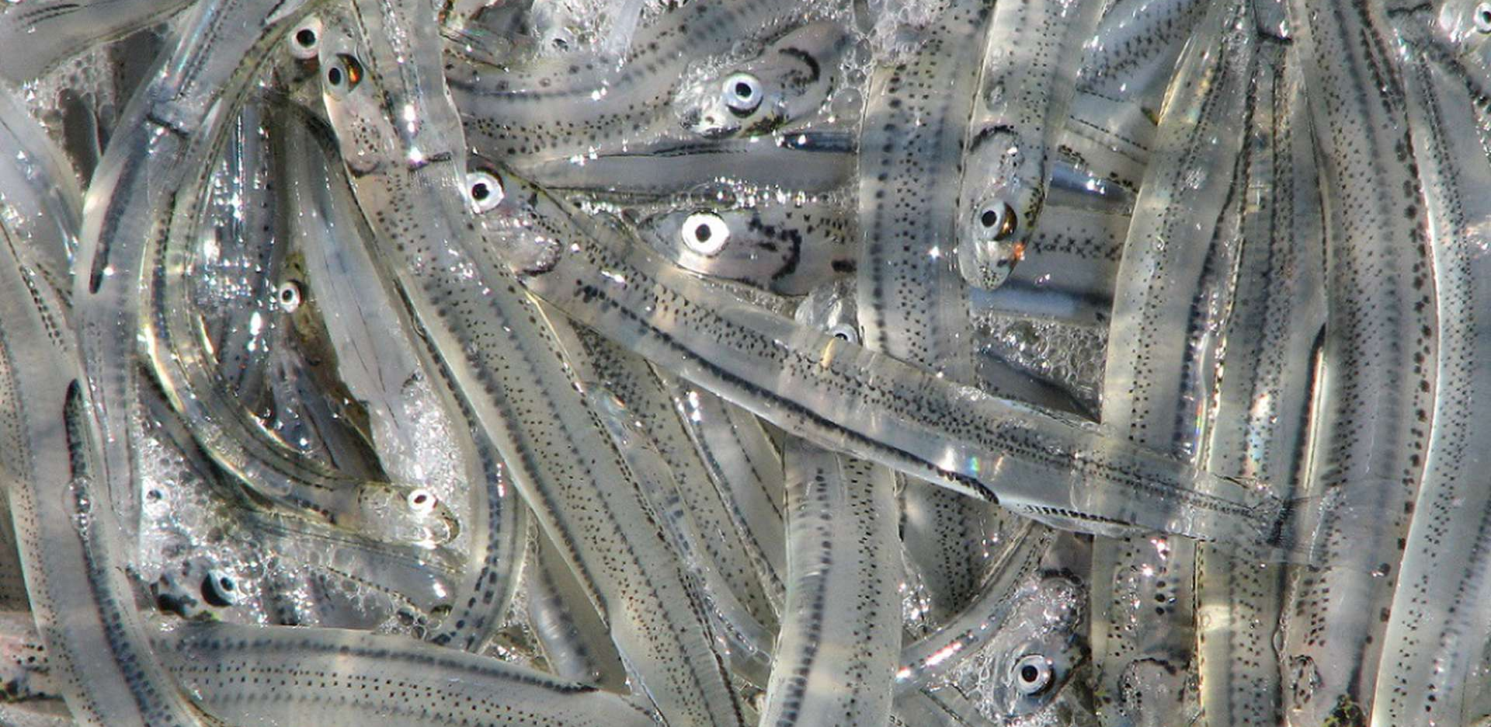
Image 5: Translucent juveniles (whitebait) during spring migration back into rivers from the ocean. The schools are typically a mixture of the juveniles of up to 6 freshwater species. Photo by DOC.
Adult Stage:
- Reach sexual maturity at approximately one year of age.
- Continue to grow through their adult life.
- Feed primarily on aquatic and terrestrial invertebrates (insects).
- Adults are often visible during daylight hours (unlike other galaxiids which are nocturnal).
- Most individuals live for only 1-2 years, though some may survive for up to 3 years.

Spawning Behaviour
Spawning Season: Īnanga spawn predominantly during autumn and winter, with the main spawning season running from March through to June. Peak spawning activity varies by region:
- East Coast populations: typically peak in March-April.
- West Coast populations: spawning may be delayed by up to one month and can extend into winter.
- Southland populations; spawning peaks in February-March.
Lunar and Tidal Influences: Spawning is precisely timed to spring tides, which occur around the new and full moon. Peak spawning typically occurs over 2-3 days after the new or full moon when spring tides are at their highest. This remarkable timing ensures:
- Maximum inundation of riparian vegetation.
- Eggs are laid above normal high tide levels.
- Eggs remain out of water during development.
- Next spring tide cycle inundates eggs to trigger hatching.
The Spawning Process:
- A few days before spawning, mature īnanga migrate downstream to the interface where fresh water (waitī) meets salt water (waitā) at the "salt wedge".
- Fish congregate in these areas, waiting for the spring tide.
- As the tide rises, shoals of īnanga work their way along the bank.
- They push into flooded vegetation at the very edge of the water, as high as the tide reaches.
- Females deposit hundreds (300) to thousands (3,000) of eggs amongst the stems of grasses and other streamside vegetation.
- Males release milt (sperm) into the water to fertilise the eggs externally (polygynandry).
- As the tide recedes, eggs remain attached to vegetation stems just above ground level.
- Spawning is energetically costly - many fish die after spawning, though some survive to spawn again in subsequent years.

Habitat Requirements
Spawning Site Characteristics: Īnanga show strong preferences for specific spawning habitats:
- Location: Upper estuarine reaches where tidal influence meets freshwater, typically in flow-stable waterways.
- Tidal influence: Sites must be inundated by spring tides but remain above normal high tide levels. Eggs become unviable in salinity levels above 21 ppt so eggs aren’t laid too far down the catchment. There is a real sweet spot, a geographically significant area where the incoming tide creates a rise in the freshwater layer on top. We call this the “Love Zone”.
- Vegetation: Dense, fine-stemmed grasses and rushes that provide:
  - Attachment substrate for eggs.
  - Shade to moderate temperature.
  - Humidity to prevent desiccation.
  - Protection from predators.
- Bank gradient: Gentle slopes that allow gradual tidal inundation. 7º - 20º is considered ideal but īnanga will spawn in unfavourable conditions if that is all that is available.
- Water quality: Clean, well-oxygenated water.
Suitable Vegetation Types: Both native and exotic vegetation can provide suitable spawning habitat:
Native species:
- Wīwī (New Zealand rush, Juncus gregiflorus).
- Oioi (Jointed wire rush, Apodasmia similis).
- Raupo (bull rush, Typha orientalis).
- Harakeke (flax, Phormium tenax).
- Toetoe (Austroderia spp., formerly Cortaderia richardii).
- Various native sedges and grasses.
Exotic species:
- Tall fescue (Festuca arundinacea).
- Kikuyu (Cenchrus clandestinus).
- Alligator weed (Alternanthera philoxeroides).
- Various other pasture grasses.
While exotic species can support spawning, some invasive species like reed sweet grass (Glyceria maxima) can be unfavourable and may displace better spawning habitat.
Adult Habitat: Adult īnanga inhabit:
- Coastal rivers and streams.
- Rivers with gentle gradients.
- Estuaries and lagoons.
- Lowland lakes (roto) and wetlands (repo).
- Slow-moving or still water areas.
Unlike other migratory galaxiids, īnanga are poor climbers and cannot negotiate waterfalls (rere) or rapid flows. They therefore do not penetrate far inland unless river gradients are very gentle.

Distribution
Global Range: Īnanga are one of the most widely distributed freshwater fish species in the world, found throughout much of the Southern Hemisphere:
- New Zealand and offshore islands.
- South-eastern Australia and Tasmania.
- Chile and Patagonia ( between 35-55°S).
- Argentina.
- Falkland Islands.
- Various Pacific islands including New Caledonia.
New Zealand Distribution: In Aotearoa, īnanga are found throughout:
- North Island.
- South Island.
- Stewart Island/Rakiura.
- Chatham Islands.
- Various other offshore islands.
They are found in suitable coastal habitats around the entire coastline of Aotearoa New Zealand. Spawning records have been located in all, regional council areas. All regions require further survey effort to fully document spawning site distribution.

4. Survey Techniques and Methodology

Pre-Survey Planning
Careful planning is essential for successful īnanga spawning surveys. Good preparation ensures safety, efficiency, and quality data collection while showing respect for the whenua and mana whenua.
Site Selection Criteria:
- A desktop study confirming that there is access to the Love Zone for both īnanga and salt water is a priority first step. Reviewing the NIWA (now ESNZ) Fish Passage Barrier Assessment Tool will show users if there are structures impeding migration and river flow.
Understanding Timing - Lunar Cycles and Tides:
Īnanga spawning is intimately connected with tidal cycles. Understanding these patterns is fundamental to successful surveying.
- Review local tide charts for high tides for timing of salt wedge surveys.
Equipment Checklist:
Refer to Appendix A for a comprehensive equipment list. Essential items include:
- Survey apps loaded on device (include offline maps if reception in your survey area is poor).
- Salinity meter.
- Measuring tape.
- 10 cm x 10 cm wire quadrat (four cells).
- 10 cm x 10 cm wire quadrat (100 cells).
- 1 m wooden ruler or pole (bamboo stake).
- Either a level or phone app to measure bank angle.
- Phone powerbank (running apps. is energy intense).
- Safety gear.
- First aid kit.
- Kayak/paddles/life vests for large rivers.
- Grab pole (for smaller rivers if not kayaking).
- Waterproof bag for phone.

Saltwater Wedge Surveys
Finding the Saltwater Wedge:

Īnanga spawning sites are located near the upstream end of the saltwater wedge - where seawater meets freshwater in tidal rivers. The saltwater wedge forms because saltwater is denser than freshwater, causing it to sink and flow along the riverbed while freshwater flows above it. This creates a wedge-shaped zone of saltwater typically extending up river. The Love Zone is considered to be approximately 240 metres long (120 m either side of the tip of the wedge) although this area varies considerably depending on the size of the stream, sometimes covering several kilometres in larger order rivers..

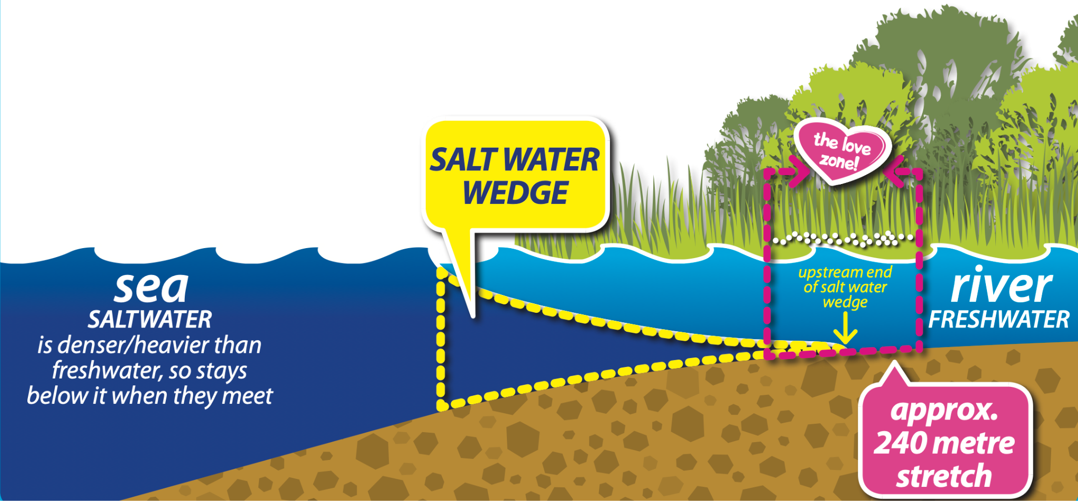
Figure 2: The salt wedge is formed by dense sea water creeping inland under the less dense freshwater layer. The peak of the wedge is where īnanga will spawn, in the Love Zoe. Image by EOS Ecology.

Key Concepts:
- Seawater salinity: ~35 parts per thousand (ppt).
- Freshwater salinity: <0.5 ppt.
- Testing must be done at the river bottom where saltwater flows, although we do take readings at mid water and surface also.
Equipment Required:
- Salinity meter with probe.
- GPS unit (if not using the NĪSP apps).
- Spawning apps or data recording sheets.
- Kayak (optional, for deep/wide rivers) with PPE e.g. lifejacket, first aid kit, and throw rope.
Survey Method:
- Conduct surveys during high spring tides (new and full moon phases).
- Start at the lower end of the waterway before high tide.
- Test salinity at both the bottom, middle, and surface.
- Move upstream, adjusting distance between test points based on readings.
- The upstream edge is where bottom salinity drops below 0.5 ppt.
- Repeat over multiple months to account for variable conditions.
Important Factors:
- Actual tide heights vary with weather and air pressure.
- Saltwater continues moving upstream after predicted high tide, there will be a lag between your observed high tide and the predicted tide at your nearest port.
- River structures (sand bars, weirs, tide gates) can block saltwater movement inland.
- Results should be averaged over several surveys.
For detailed procedures see Salt Wedge Surveys. Link includes a printable version of the data sheet. It is recommended that you have this with you even if you intend to use the apps in case there is some issue with your phone or the tech.

Calibrating your Salinity Meter
The Gold Standard for meter calibration is to calibrate immediately before and after each survey.

Refer to Envco links:

YSI Pro30
YSI Pro Plus
YSI Pro Quatro

Finding and Assessing Spawning Habitats
When to Search:
Īnanga spawn primarily from March to early June, with peak activity in April, but varies regionally. Spawning occurs for 2–3 days over the highest spring tides (which follow new or full moons). Before searching for eggs, visit the site during a spring high tide to mark the high water level on riverbanks with a series of bamboo stakes - this is often much higher than expected. Search for eggs at low tide across a 1 m wide band that spans the line you have marked with the stakes.

Where to Search:
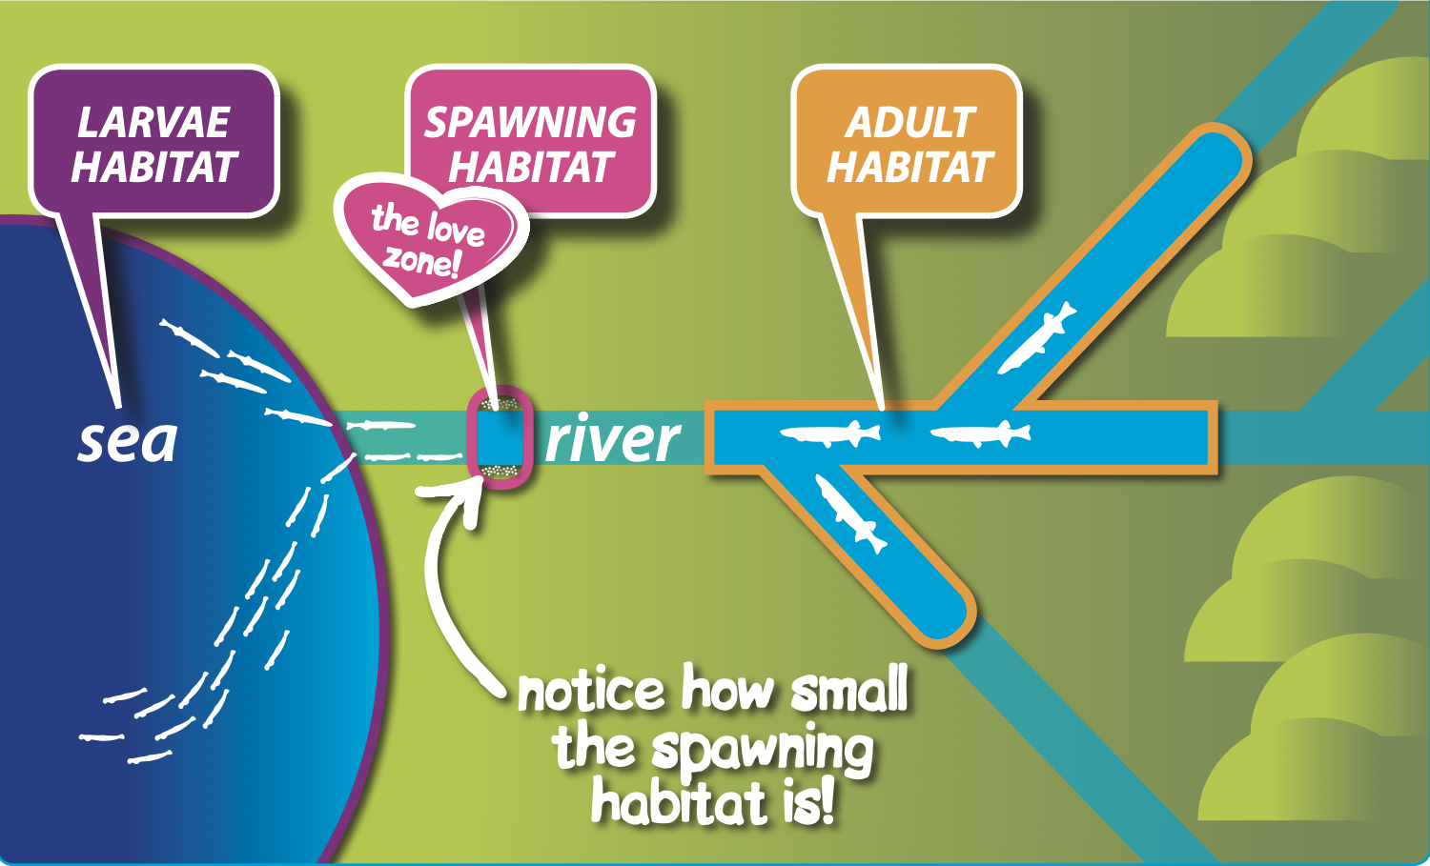
Figure 3: The Love Zone is a geographically small area where conditions are right for spawning. Image by EOS Ecology.
1. Distance from the sea: Spawning typically occurs close to the upstream limit of saltwater penetration. This can be determined by testing bottom water salinity in the deepest part of the stream channel at high tide using a salinity meter. Note that saltwater extent varies significantly day-to-day depending on things like tide size, rain fall, strength and direction of wind direction, and barometric pressure.
2. Access to the bank: Look for gentle natural slopes that spring tides can easily cover.
3. Bank vegetation
- Search upstream of salt-tolerant plants (eggs rarely found among Cotula coronopifolia (Bachelor’s Button), Juncus kraussii (Saltmarsh Rush), Apodasmia similis (Jointed Rush, Oioi), or Schoenoplectus pungens (Sharp club-rush).
- Focus on tall, dense vegetation clumps that maintain moisture and protect eggs from temperature variations and UV radiation.
- Eggs commonly found in Schedonorus phoenix (tall fescue), Agrostis stolonifera (creeping bent), or Juncus edgariae (Edgar's rush).
- Prioritize shaded banks where vegetation is lusher and soil remains moist - avoid dry or sandy areas.
Search Technique: Get low and search thoroughly at ground level. Pull apart vegetation with effort - eggs don't reveal themselves easily. Be mindful that you are in a spawning site and try to minimise your impact whilst searching. When you find a clump of eggs close up the hole you have created in the vegetation and mark it with a flag. Continue to search and mark clumps until you can’t find any more. Remember, UV light destroys īnanga eggs. Try shading your search area with your shadow, or have an umbrella in your survey kit.
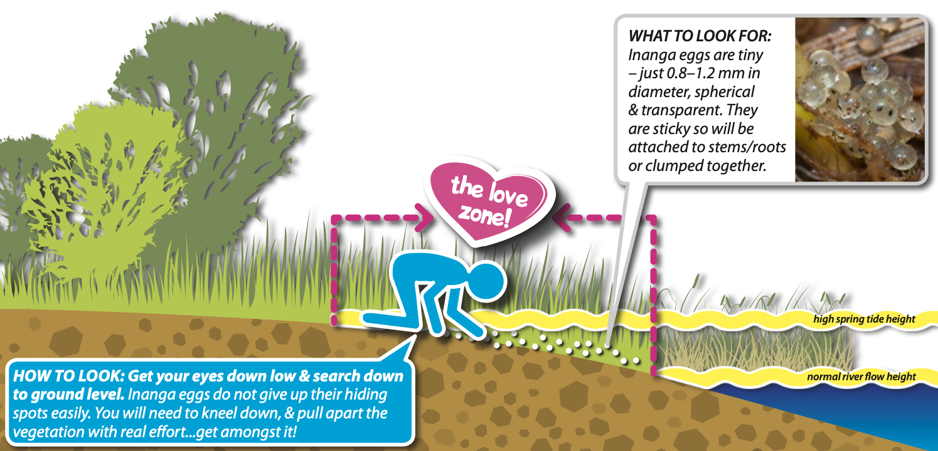
Figure 4: Systematically search the spawning site along a 1 m band that spans the high tide mark. Be aware that your presence is damaging to these precious sites, so move with care. Image by EOS Ecology.
Egg Identification: Īnanga eggs are tiny (0.8–1.2 mm diameter), spherical, transparent, and sticky. They attach to stems/roots or clump together. They can appear similar to slug and snail eggs, which are also laid in riparian vegetation.
Key differences:
- Īnanga eggs are perfectly spherical, whilst slug and snail eggs are slightly oval.
- Īnanga eggs are approximately 1 mm in diameter, whilst slug and snail eggs are typically larger, 2-3 mm in diameter.
- Īnanga eggs are transparent (unless unfertilised where they will appear cloudy), whilst slug and snail eggs are slightly opaque.
- Īnanga eggs are typically very numerous and well spread throughout the grass stems, whilst slug and snail eggs are usually few in number (2-12) and typically clustered upon each other.
- Tip: waiting for one week after the last day of the highest tides often gives the īnanga eggs enough time to develop eye-spots. Slug and snail eggs do not develop eye-spots. If in doubt, take a few eggs home in a dark airtight container with some moist vegetation and watch for eye spot development. The old film canisters are perfect for this application.
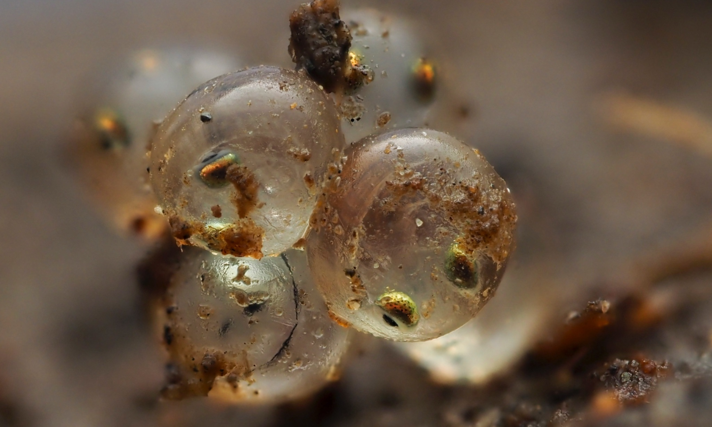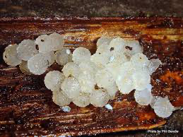
Image 6: After about 1 week paired eye-spots appear in īnanga eggs (Left. Photo by Dr. Emily Roberts). This is a defining feature that eliminates confusion with slug and snail eggs. Slug and snail eggs are often opaque, and oval shaped (Right.Photo by Manaaki Whenua).
For more detailed information, see Finding Spawning Habitats.

Habitat Assessment Survey
Importance of Habitat Quality:
- Most female īnanga only have one opportunity to spawn. Good quality spawning habitat enables more eggs to survive and begin their journey to becoming whitebait - poor quality habitat can result in total egg loss.
Historic vs. Contemporary Habitat
Historic (pre-European settlement): Tidally influenced riparian zones featured tall overarching forest and scrub (kowhai, patē, manatu, kahikatea, ti kouka) and tall tussock species (harakeke, carex sedges, wīwī). This canopy shaded and sheltered banks, supporting loose undergrowth of sedges, herbs, and mosses. Īnanga spawned within the root masses of these plants and associated plant litter.
Contemporary: Most spawning sites are now dominated by exotic grasses. Īnanga eggs are frequently found attached to tall fescue (Schedonorus phoenix) and kikuyu (Cenchrus clandestinus), with creeping bent (Agrostis stolonifera) and Yorkshire fog (Holcus lanatus) in lower proportions. Exotic herbs like clover, monkey musk, and buttercup are favoured but rarely dominate.
Habitat Assessment Process
The Īnanga Spawning Habitat Assessment Sheet evaluates spawning sites across twelve attribute criteria. One sheet is required per site.
Assessment Criteria (0, 5, or 10 points each):
- Fish access - Barriers to upstream īnanga movement.
- Saltwater access - Barriers to saltwater penetration.
- Bank angle - Optimal range 7–20° (measured over 1m band spanning high spring tide mark).
- Bank material - Best: continuous earth/loam soil.
- Vegetation cover - Best: >75% ground coverage.
- Vegetation type - Best: pasture grasses/rushes (tall fescue, creeping bent, Edgar's rush).
- Root mat thickness - Best: dense, hard to pull apart.
- Vegetation height - Optimal: 21–50 cm (acceptable: 10–20 cm).
- Ground moisture - Best: damp or wet throughout.
- Cover for fish - Best: at least two types (emergent plants, overhanging vegetation, submerged plants, logs/boulders).
- Bank maintenance - Best: not regularly mowed, or mowed >2 months before spawning season.
- Livestock protection (rural areas) - Best: permanent fencing preventing all access.
Scoring:
- 90–120 points: Good spawning habitat.
- 55–90 points: OK, but improvements needed.
- Any single 0 score: Spawning unlikely - improvements essential.
For the complete assessment sheet and detailed criteria, see Assessing Īnanga Spawning Habitats. Link includes a printable version of the data sheet. It is recommended that you have this with you even if you intend to use the apps in case there is some issue with your phone or the tech.
Tips and Tricks: Complete Habitat Assessment Surveys (HAS) at the beginning and end of each season to track the quality of the habitat over time. If you find eggs it is essential that you complete a HAS, if you haven't already for the site, so that ground truthed spawning sites have their 12 attribute criteria recorded.

Quantifying Eggs
Counting Īnanga Eggs – Assessing Spawning Activity
Counting īnanga eggs laid in the ‘Love Zone' over a spawning season provides an effective way to assess spawning activity and compare activity over time. A scientific method called 'random stratified sampling' is used to quantify egg numbers without needing to count every individual egg, making the process faster and more consistent between sites.
Quantifying Eggs in Natural Habitat
Prerequisites:
- The ‘Love Zone' identified (the section of river most likely to contain eggs).
- Survey conducted at low tide.
Equipment needed:
- Flags/flagging tape.
- Tape measure.
- 10×10 cm wire quadrat with 5 cm grid squares.
- 10×10 cm wire quadrat with 1 cm grid squares.
- Data recording equipment (apps and paper version as backup).
Survey Method:
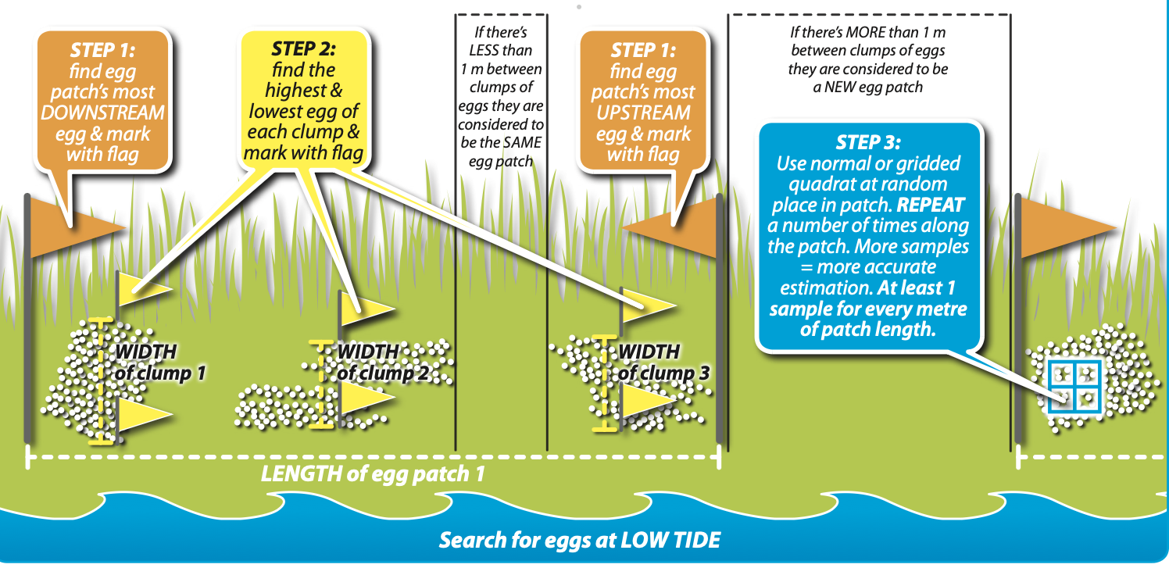
Figure 5. Patches are made up of clumps. Where there is greater than 1 m between clumps this becomes a new patch. Image by EOS Ecology.

Step 1: Quantifying eggs in their natural habitat takes several steps.
- An egg patch comprises multiple smaller 'clumps' of eggs.
- Clumps less than 1 m apart = same patch.
- Clumps more than 1 m apart = separate patches.
- Mark most upstream and downstream eggs with flags.
- Measure patch length and width of each clump.
Calculate area: AREA (m²) = patch length × average clump width (average clump width = all clump widths added together ÷ number of clumps)
Step 2: Estimate egg numbers
- Randomly place a 10×10 cm quadrat within the egg patch.
- If <200 eggs in quadrat: count all eggs.
- If >200 eggs: use a gridded quadrat, count eggs in 5 random squares (out of 100), multiply by 20.
- Repeat sampling at least once per square metre of patch length, or as directed by the survey app.
- Record zero if no eggs present in a square.

Calculate density and productivity:
- DENSITY (eggs per m²) = average number of eggs in all quadrat counts × 100 (average = all quadrat totals for that patch added together ÷ number of quadrats counted).
- PRODUCTIVITY (total eggs) = AREA × DENSITY.
Quantifying Eggs in Temporary Straw Bale Habitat
Use the same AREA and DENSITY calculation methods, but follow a systematic survey sequence:
Equipment needed (additional):
- Sun umbrella (critical - eggs dry out and die quickly in the sun).
- 1×0.5 m AREA grid with 5×5 cm grid squares.
- 10×10 cm DENSITY quadrats (standard and gridded).
- Equipment to remove/replace bales.
Survey Sequence:
Surface 1: Ground perimeter (0.5 m around bales)
- Place a large grid 6 times to cover the entire perimeter.
- If no eggs found: record zero, move to Surface 2.
- If eggs found: complete AREA and DENSITY counts.
Surface 2: Bale interior surfaces (where bales touch)
- Place a large grid twice (once per bale).
- If no eggs found: record zero, move to Surface 3.
- If eggs found: complete AREA and DENSITY counts.
Surface 3: Ground underneath bales
- Place the large grid twice (once under each bale).
- If eggs stuck to the bale bottom, count those instead of ground (don't count both).
- If no eggs found: record zero, survey complete.
- If eggs found: complete AREA and DENSITY counts.
Critical Safety Note: Always ensure bales are shaded from sun before starting. Handle bales carefully when rolling to prevent damage to eggs.
Area and Density Counting Methods When Eggs Are Found:
1) Define AREA (counting grid squares):
- Use a 1×0.5 m large area grid with 5×5 cm squares.
- Apply the grid to the surface where eggs were found.
- Count number of 5×5 cm grid squares containing eggs.
- Repeat as needed per survey sequence (6 times on grass perimeter, once per bale interior surface, once under each bale).
Calculate area: AREA = number of grid squares with eggs × 0.0025
2) Define DENSITY (counting eggs): Use ONE of the following methods for representative egg counts. Repeat up to 3 times per surface in different random spots:
If LESS than 200 eggs: Use 10×10 cm quadrat
- Count all eggs within the whole quadrat (all 4 squares).
- This total = one quadrat count.
If MORE than 200 eggs: Use 10×10 cm quadrat with 1×1 cm squares
- Count all eggs in only 5 random grid squares.
- Multiply that number by 20.
- This total = one quadrat count.
Record zero if no eggs are found in a quadrat/square.
Calculate density and productivity: Once all appropriate quadrat counts are completed and averages calculated:
- DENSITY = average* number of eggs in all quadrat counts × 100.
- PRODUCTIVITY = AREA × DENSITY.
*Average = all quadrat totals for that bale set added together ÷ number of quadrats counted
Further Resources:
- For instructions on finding 'the love zone' see Whitebait Connection NĪSP resource 2a: Finding natural spawning sites.
- For equipment list for shifting bales see Whitebait Connection NĪSP resource 3a: Install temporary spawning habitat.
- Local tide tables: www.linz.govt.nz/hydro.
For complete detailed methods with visual guides, see Counting Eggs.

Installing Artificial Spawning Habitat
Īnanga spawning and egg survival are closely linked to the availability of good quality spawning habitat. If natural riparian vegetation is damaged or still developing, straw or hay bales make effective temporary spawning habitat for a season.
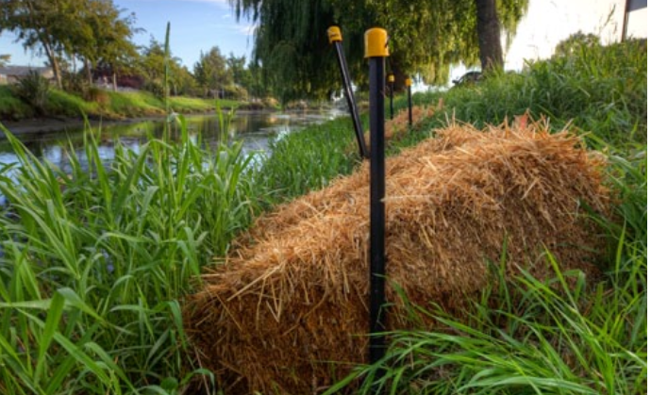
Image 7: Straw bales make excellent temporary īnanga spawning habitat whilst waiting for riparian vegetation to recover from grazing/mowing etc. Photo by EOS Ecology.
Basic Concept
When straw bales are placed with long sides parallel, the crevice between them creates:
- Accessible spawning area for īnanga.
- Shade from the sun.
- A moist and cool environment.
= GREAT TEMPORARY ĪNANGA SPAWNING HABITAT!
Why Straw/Hay Bales?
Wheat straw, barley straw, or hay bales are effective because they are:
- Robust.
- Biodegradable.
- Cheap.
- Effective short-term substitute for native riparian vegetation.
Ideally, install several bale sets at multiple sites across the known or suspected spawning area.
Before You Start:
- Ensure you're in the right part of the river and at the right height up the bank for spring tides.
- Obtain permission from appropriate authorities and landowners before beginning any work.
Installation Equipment Needed (per bale set):
- 2× straw/hay bales.
- 2× 1.5 m metal stakes (waratahs).
- 2× hi viz stake safety caps.
- 3–4 m of 4 mm wire.
- 1× site label.
- 3× 30 cm cable ties.
- 1× 45 cm wooden stake.
- Mallet/club hammer/post driver for metal stakes.
- Wirecutters/pliers for wire.
- Usual safety gear.
- Willing helpers!
Installation Method:
Step 1: Mark the high water level
- Visit the site during several spring high tides.
- Mark the highest point the water reaches on the bank (highwater mark) with bamboo stakes.
Step 2: Schedule installation
- Head out at low tide to install bales.
- Install a couple of weeks before the spawning spring tide so bales have time to 'season'.
Step 3: Position the bales
- Place bales just below the highwater mark, but above normal river flow height.
- Lay them long sides next to each other, at right angles to the river (gap pointing down).
- Leave a 50 mm gap between the bales. This ensures the tide inundates the gap between bales.
- TIP: Always carry bales by holding BOTH twines to prevent them falling apart.
Step 4: Install metal stakes
- Place metal stakes halfway down the length of the two bales, snug on the outside.
- Hammer in until firmly in place.
- Position a wire hole in the metal stake against each bale, level with the top of the bale.
Step 5: Prepare wire
- Cut a piece of wire 2.5 times as long as the distance between the two hammered metal stakes.
Step 6: Start wire threading
- Make a secure loop in one end of the wire.
- Thread the straight end through the hole in the metal stake level with the top of the bales.
- Pull through until the loop sits in the middle between the two bales.
Step 7: Secure wire at first stake
- Bend the wire at the hole in the metal stake to firmly secure.
- Thread the straight end through the opposite metal stake.
- Secure with a solid bend.
- Thread it back through the initial loop at the centre.
Step 9: Final wire securing
- Secure the final piece of wire through the loop back on itself.
- Push any leftover ends safely into the bale.
Step 10: Tighten installation
- Hammer the metal stakes deeper into the ground to tighten the wires.
- Ensure bales are firmly held against the ground for when spring tides arrive
- Bales shouldn't move when kicked.
Step 11: Final touches
- Attach hi viz safety caps to the top of the metal stakes with cable ties.
- Attach the site label to the top of the metal stakes with cable ties.
Key Installation Points:
- Bales positioned side-by-side with a 50 mm gap between, pointing down towards the water.
- Metal stakes firmly hammered in halfway down the length of the bales, with safety caps held in place with cable ties.
- Wooden stake marks the highwater mark location.
- Bales sit between the highwater mark and normal river flow height.
Tips and Tricks: Try laying the bales on top of a few broken branches (old harakeke flower stalks work well) to create a gap under the bales also. This can provide additional spawning area. Don’t forget to look for eggs between, and under the bales. In the perfect world the top edge of the gap between the bales closes but the gap below remains open. This ensures that light is omitted meaning the gap stays dark and moist.
For a complete visual installation guide and detailed specifications, see Installing Artificial Spawning Habitat.

5. Using the Survey Apps

Getting Started
The National Īnanga Spawning Programme has developed two custom apps within FieldMaps and Survey123. There are two versions available, for iPhone and Android users. Standardised surveys using proven field techniques and modern data collection tools enable:
- Accurate identification and mapping of spawning sites.
- Consistent monitoring of spawning activity.
- Assessment of habitat quality and threatening processes.
- Informed decision-making for conservation management.
- Coordinated restoration efforts at sites of highest priority.

See links to Quick Guides:
The purpose of these Quick Guides is to print and laminate for field use. They have been designed to fit on a single A4 page, double sided.
- iPhone version_Saltwater Limit Survey_Quick Guide
- iPhone version_Habitat Assessment_Quick Guide
- iPhone Version_Spawning Activity Survey_Quick Guide

- Android version_Saltwater Limit Survey_Quick Guide
- Android version_Habitat Assessment_Quick Guide
- Android version_Spawning Activity Survey_Quick Guide
Tips for Field Use
Battery Management:
- Download offline maps for areas where network connectivity is low.
- Charge devices fully before heading out.
- Carry portable battery pack.
- Use airplane mode when not syncing to conserve battery.
- Reduce screen brightness.
- Close unnecessary apps.
- Have backup paper forms in case of visibility issues.

Protecting Device in Wet Conditions:
- Use a waterproof case or bag.
- Keep spare dry cloth for wiping the screen.
- Avoid use in heavy rain if possible.
- Have a backup device or paper recording as a contingency.
Working Offline:
- Apps designed to work without internet connection in the field.
- Sync data when you return to wifi/cellular coverage.
- Check that offline functionality is enabled before leaving.

6. The Data Hub - Access and Navigation

Accessing the Hub
The National Īnanga Spawning Database Hub is the central repository for all spawning site data collected through this programme. It allows you to view and edit your own data, explore regional patterns, and contribute to national conservation efforts. All of your/your organisation's data can be downloaded upon request.
Website: Link here
Dashboard Overview
- Main dashboard features:
  - A welcome to the NĪSP Hub and a short film by Wendy Bown titled: Streams of Life: Restoring Īnanga Habitat in Northland.
  - Links to Whitebait Connection and Mountains to Sea Facebook pages for sharing your īnanga stories.
  - “How to” video series.
  - Survey Data Map.
  - Data Dashboards.
- View your own survey data.
- Access regional and national data.
- Data downloads for your agency upon request.
Guide to using the Hub coming soon…
Contributing to the National Database
Every survey you complete contributes to a growing understanding of īnanga spawning sites across Aotearoa. Your data:
- Helps identify priority sites for protection.
- Informs regional and national conservation planning.
- Supports research into īnanga ecology and spawning habitat.
- Contributes to mahinga kai restoration efforts.
- Enables tracking of long-term trends.
- Supports mana whenua in their kaitiaki role.
Data Sharing Protocols:
- MTSCT are stewards of the data
- All users of the NĪSP apps and Data Hub must abide by the Code of Conduct
- Data sharing between users/organisations must be done with consideration of local mana whenua
- MTSCT has integrated the Local Contexts digital data labelling system within the NĪSP Hub as a mechanism for guaranteeing data sovereignty to mana whenua. Local Contexts aims to “ground intellectual and cultural property rights in cultural heritage, data, and genetic resources within digital environments”.
Respecting Mātauranga
The Hub contains information that may be culturally sensitive, including locations of mahinga kai and sites of significance to mana whenua. Users must:
- Respect the cultural significance of spawning sites.
- Use data appropriately and ethically.
- Follow any access restrictions on sensitive sites.
- Acknowledge mātauranga Māori in any use of data.
- Work in partnership with iwi when using data from their rohe.
Technical Support
For Hub access or technical issues, contact: Nic Nasymith

7. Tips and Tricks for Effective Surveying
This section contains practical wisdom gathered from experienced surveyors across Aotearoa. These tips will help you work more efficiently and effectively in the field.

Timing Your Survey
You need to have a good understanding of the optimal Tide and Moon Phase Combinations. Understanding the maramataka (lunar calendar) and tidal patterns is crucial.
Saltwater Wedges:
- Spawning season varies across the country, but generally starts around March. Start your saltwater wedge surveys at this time. On very small awa a single SWWS is enough to gauge where your Love Zone is and where to start searching for eggs. On larger awa a minimum of 3 SWWS should be conducted to narrow down your search area. As long as your wedges fall within close proximity to each other you can be reasonably sure you are in the Love Zone.
- Surveys can be conducted for 2-3 days after the new and full moons when tides are at their highest for the month.
- Avoid surveying for at least two days after significant rainfall, or if significant rainfall is predicted during the planned survey. The saltwater wedge is likely to be pushed further upstream during low flow/rainfall months and further downstream during high flow/rainfall months so plan your entry point accordingly. Always plan to be paddling upstream during the incoming tide and downstream during the receding tide.
- Be on your awa approximately 1 hr prior to the predicted high tide time. Take a bottom reading at your entry point. Do not record this data point. If it is already salty (>5-10 ppt) you can start to record your data points. Slowly move upstream following the incoming tide and take regular readings until you find a bottom reading of 0.5 ppt at the top of the tide. If your entry point reading is fresh (<0.5 ppt) you need to head down stream until you reach a point where the bottom is reading 5 -1 0 ppt. Don’t record any of these points as you search. Now, turn back upstream following the incoming tide until you find a bottom reading of 0.5 ppt at the top of the tide.
- The Hub software works best when the sequence of salinity data points is collected in one direction, preferably in an upstream direction, with data collected at bends in the river.

Habitat Assessments:
- Best to survey at low tide along the 1 m wide band marked at the spring high tide at both the beginning and end of each season. Avoid surveying for at least two days after significant rainfall, or if significant rainfall is predicted during the planned survey as rainfall affects the inward progression of the salt water wedge and the associated tidal lift.
Spawning (Egg) Surveys:
- Avoid surveying after significant rainfall, or if significant rainfall is predicted during the planned survey. Aim to survey approximately 7-10 days after the most recent spring tide cycle. Search along the 1 m wide band of the high tide mark you have indicated with bamboo. Search at low tide. Be systematic with your searches.
Finding Spawning Sites
Visual Cues to Look For: These vary with regions so understanding your regional visual cues can be important. As an example, in Northland we wouldn’t search below the area where mangroves begin to appear. Where crab holes begin to diminish is a good starting point to search upstream. The plants Bachelors Button and Saltmarsh Ribbonwood indicate salty condition also, so search above these indicators. So, consider your regional:
- Vegetation indicators
- Geomorphological features
- Tidal indicators (wrack lines, debris)
- Fish activity (īnanga congregating, mullet will often push right up to the top of the salt wedge)
Common Spawning Locations:
- Back eddies off the main river flow at benches are popular for spawning.
- Īnanga seem to have a preference for spawning at the confluences of tributaries that fall within the Love Zone.
- Benches with thick vegetation and dappled shade are common spawning locations.
- Gentle sloping banks are preferred.
Using Mātauranga Māori: Local iwi and kaumātua and kuia often hold valuable knowledge about:
- Historic spawning locations.
- Seasonal patterns and maramataka.
- Changes in spawning sites over time.
- Traditional mahinga kai practices. This knowledge should be sought respectfully and used appropriately in partnership with mana whenua.
Working Efficiently in the Field
Team Coordination Strategies:
- Minimal group numbers - ideally 1-3 max to prevent excessive trampling during egg searches.
- Communication methods - have VHF or InReach devices when in remote areas. Let a shorebased person know where you’re going and when you’re expected back and what to do if you don’t return.
- 1 gathers/surveys the site while the other enters the data.
- Documentation responsibilities.
Time Management:
- How long to allocate per site - up to 3 hours for SWW, full day for egg searches, full day for habitat assessments.
- Prioritising when time is limited: Prioritise egg searches over salt wedges.
- Egg search once per month at each site to allow for vegetation to recover.
- Refer to Appendix C for example of seasonal survey plan.
Common Challenges and Solutions
Poor Visibility Conditions: Challenge: Harsh sunlight makes egg detection difficult Solutions: Overcast days are ideal for visibility, with less UV thus minimising damage to exposed eggs. Rain can make conditions under foot muddy causing more damage to your site. Water droplets can look like eggs at first glance.
Access Issues: Challenge: Site is on private property, across difficult terrain, or behind locked gates Solutions: Drop a letter in the private landowner's mailbox explaining why you’re surveying and asking them to contact you about potentially accessing through their property (we have a template somewhere for this). Safety first - if you can’t reach a site safely or with landowner permission,, don’t do it.
Inclement Weather: Challenge: Rain, wind, or extreme temperatures during survey Solutions: Always wear appropriate PPE, stay hydrated and avoid long survey days during heat waves or high rainfall events. Avoid doing surveys under tall trees during high winds especially if the ground is saturated from recent rainfall as trees may be more prone to being blown over,
Equipment Failures: Device battery dies, GPS not working, app crashes. Solutions: Waterproof paper versions of the survey sheets. GPS tracker for location. Back up battery pack.
Uncertainty About Eggs: Not sure if what you've found are īnanga eggs
Solutions:
- Photograph and upload to group for I.D.
- Compare with reference images.
- Contact experienced surveyors for verification.
Field Craft and Tikanga
Minimising Disturbance:
- Move carefully through vegetation.
- Avoid trampling potential spawning areas.
- Disturb eggs as little as possible.
- Ensure eggs are shaded when found (either in your shadow or shadow of umbrella).
- Leave the site as you found it.
Showing Respect for the Whenua:
- Karakia (if appropriate and with guidance).
- Acknowledgement of mana whenua.
- Gratitude for access to these special places.
- Care and attention in your mahi.
- Leaving sites better than you found them.
Learning from Each Survey:
- Keep detailed notes beyond app fields.
- Record what worked and what didn't.
- Note unusual observations.
- Share learnings with other surveyors.
- Build your understanding of local patterns.
Regional Variations
Īnanga spawning ecology varies across regions. Connect with your regional coordinator to learn about:
- Local spawning season timing.
- Characteristic spawning sites in your rohe.
- Dominant vegetation types.
- Tidal patterns and influences.
- Local challenges and solutions.
- Mātauranga relevant to your area.

8. Restoration Planning and Best Practices
Assessing Restoration Potential
Not all degraded sites are suitable candidates for restoration. A systematic assessment helps prioritise efforts and resources where they'll have the greatest impact.
Site Evaluation Criteria:
Essential Requirements:
- Appropriate tidal regime (site must be inundated by spring high tides).
- Fish access from sea (no impassable fish passage barriers).
- Landowner support and long-term commitment.
Desirable Features:
- Proximity to existing spawning sites (source populations nearby).
- Historical evidence of spawning (local knowledge, old records).
- Suitable bank gradient and aspect.
- Some remnant appropriate vegetation present.
- Community and/or iwi support for restoration.
- Secure land tenure (protected status, covenant, or supportive landowner).
- Prioritise smaller awa first, including tributaries of a large awa that fall within the Love Zone.
Red Flags (consider carefully):
- Severe water quality issues (may need to address catchment-wide problems first).
- Ongoing heavy stock access with no fencing commitment.
- Regular disturbance (mowing, development) that cannot be modified.
- Very steep banks with no suitable spawning zone.
- Imminent development or land use change (check with council).
- High predator (trout) pressure with no control feasible.
Prioritisation Framework:
You might want to consider calculating a priority score:
- Ecological value (0-10 points):
  - Connectivity to other sites.
  - Regional significance.
  - Habitat quality potential.
- Feasibility (0-10 points):
  - Technical difficulty.
  - Cost.
  - Landowner support.
- Impact potential (0-10 points):
  - Expected spawning site area gain.
  - Population benefit.
  - Risk of failure.
- Community engagement (0-10 points):
  - Volunteer interest.
  - Education opportunities
  - Cultural significance
Sites scoring 30+ are high priority; 20-29 medium priority; below 20 should be reconsidered.

Restoration Techniques
Vegetation Enhancement
Establishing or improving riparian vegetation is often considered a critical restoration action. It reestablishes native biodiversity, creates shade, helps to stabilise river banks, and can aid in reducing runoff from land. Established riparian margins bring in large numbers of invertebrates, which are crucial food for our native freshwater fish species.
However, if funding and capacity is limited, the best interventions are protecting the existing vegetation from mowing/grazing/trampling, and the development of an effective pest mammal (rats and mice) eradication programme. If money and time are not limited, then planting would be the next most important intervention.
Site Preparation:
- Remove weed species that will compete with plantings.
- Control pest plants using appropriate methods (hand pulling, cutting, herbicide if necessary).
- Prepare planting areas without creating bare, eroding ground.
- Consider timing - avoid spawning season for major earthworks.
- Protect existing suitable vegetation during restoration works.
Native Plant Selection:
Grasses and rushes (primary spawning substrate):
- Wīwī (Juncus gregiflorus) - excellent spawning substrate, fast-growing.
- Oioi (Apodasmia similis) - salt-tolerant, suitable for lower estuarine sites.
- Native sedges (Carex spp., particularly C. secta, C. virgata) - good egg attachment.
- Pūrei (Carex lambertiana) - coastal sedge.
- Toetoe (Austroderia spp.) - larger grass, good for upper banks.
Supporting species (stabilisation, diversity, habitat):
- Harakeke (Phormium tenax) - structural plant, shelters smaller species. Plant well back from the river's edge and away from steep slopes.
- Mānuka (Leptospermum scoparium) - provides shade, stabilises banks.
- Kōwhai (Sophora spp.) - shade, bank stability.
- Kānuka (Kunzea spp.) - fast-growing, stabilising.
- Cabbage trees/Ti kouka (Cordyline australis) - hardy, tolerates wet conditions.
- Lowland ribbonwood/Mānatu (Plagianthus regius) - fast growing, stabilises banks.
- Saltmarsh ribbonwood/Mākaka (Plagianthus divaricatus) - fast growing, stabilises banks.
Timing considerations:
- General riparian planting: Plant during cooler, wetter months (autumn to early spring), and avoid disturbing existing spawning vegetation.
- Spawning bench augmentation: Avoid planting during peak spawning season, if possible.
- Allow 2-3 years for vegetation to mature into suitable spawning habitat.
Planting Design and Spacing:
- Dense planting in the spawning zone (30-50cm spacing for grasses/rushes).
- Wider spacing for larger structural plants (1-2m).
- Create graduated zones from water's edge to bank top.
- Mix species for resilience and habitat diversity.
- Consider final vegetation height on north side of spawning sites so as to avoid complete shading of spawning grasses.
- Plant in blocks or drifts rather than rows for natural appearance.
- Consider using plant guards in areas where rabbits are a problem or regular scrub cutting will be required to maintain weeds.
For more detail refer to the Plants for Restoring Spawning Habitat Guide
Maintenance Schedules:
First 6-12 months (establishment phase):
- Monthly weed control around plants.
- Replace failed plants (target >90% survival).
- Water during dry periods if practical.
- Protect from stock, pests, and disturbance.
- Monitor for pest plant regrowth.
Years 1-3 (growth phase):
- Regular weed control (monthly to quarterly).
- Infill planting to achieve desired density.
- Maintain stock exclusion.
- Control predators.
- Remove dead or diseased plants.
Years 3+ (maintenance phase):
- Annual weed control.
- Replace plants as needed.
- Monitor spawning activity.
- Adaptive management based on results.
- Ongoing predator control.
Habitat Modification
Physical changes to banks and water edges can significantly improve spawning habitat.
Bank Profiling:
- Reduce gradient of steep banks where feasible.
- Create gentle slopes (7-20°) to extend the spawning zone.
- Ensure work doesn't increase erosion risk.
- Requires resource consent in most regions.
- Best undertaken in the dry season, outside spawning period.
Stock Exclusion Fencing:
- Essential for most farm sites.
- Fence set back far enough to protect the entire spawning zone.
- Use appropriate fence type (standards, posts, wire).
- Provide alternative stock water.
- Maintain fence integrity.
- Consider gates for access at appropriate locations.
- May qualify for council or government funding support.
Water Quality Improvement
Poor water quality can limit restoration success. While spawning site restoration can proceed with moderate water quality issues, significant pollution needs addressing.
Identifying Pollution Sources:
- Conduct water quality testing (before and during restoration).
- Identify upstream sources (agriculture, urban stormwater, industrial).
- Document problem times (rain events, dry weather, seasonal).
- Engage with catchment-level initiatives.
- Report significant pollution to the regional council.
Riparian Buffer Establishment:
- Widen riparian buffer zone beyond minimum spawning habitat.
- Plant deep-rooted species to filter nutrients.
- Establish vegetated buffers on both banks if possible.
- Link with upstream and downstream buffer zones.
- Typical width: 3-20m depending on site and land use.
Sediment Control Measures:
- Address upstream erosion sources where possible.
- Stabilise bare banks immediately upstream.
- Install sediment traps if appropriate.
- Maintain ground cover during restoration works.
- Use erosion control matting on newly planted areas.
- Monitor for sediment deposition on spawning sites.
Collaborative Approaches:
- Work with catchment management groups.
- Engage with other landowners in catchment.
- Support council riparian management programmes.
- Participate in catchment-scale water quality initiatives.
- Share information and resources.
Monitoring Restoration Success
Establishing Baselines: Before restoration begins, document:
- Current site condition (Habitat Assessments at start of season).
- Any existing spawning activity.
- Water quality parameters.
- Predator activity.
- Weed species and coverage.
- Erosion or other degradation.
Short-term Indicators (Years 1-3):
- Increasing Habitat Assessment scores.
- Increased productivity (seeing more eggs).
- Plant survival and growth rates.
- Weed control effectiveness.
- Predator numbers (trap catches dropping).
- Water quality trends.
- Bank stability.
- Public awareness and engagement.
Medium-term Indicators (Years 3-5):
- Vegetation maturity and structure
- Increasing evidence of spawning activity
- Egg presence and density
- Predator control success
- Site stability
Long-term Indicators (Years 5+):
- Consistent spawning activity.
- Egg density comparable to good natural sites.
- Juvenile recruitment.
- Self-sustaining vegetation community.
- Minimal ongoing intervention required.
- Community ownership and pride in site.
Long-term Monitoring Protocols
Annual Monitoring (minimum):
- Spawning season surveys (at least 2-3 times per season).
- Vegetation condition assessment.
- Weed and pest monitoring.
- Photo points (same locations each year).
- Predator control results.
- Maintenance needs identified.
Periodic Detailed Assessment (every 3-5 years):
- Comprehensive vegetation surveys.
- Habitat quality scoring.
- Water quality testing.
- Comparative analysis with baseline data.
- Stakeholder feedback and engagement assessment.
Data Management:
- Maintain consistent records year to year.
- Upload all data to National Īnanga SpawningProgramme Database.
- Share results with community and partners.
- Use data to inform adaptive management.
- Contribute to regional and national trend analysis.
Adaptive Management Approaches
Restoration is an iterative process. Use monitoring results to guide ongoing management:
If plants aren't establishing:
- Review species selection (are they appropriate for the site?).
- Check soil moisture and drainage.
- Increase weed control effort.
- Assess pest animal impacts.
- Consider plant guards
If spawning doesn't occur:
- Confirm fish can access the site.
- Check tidal inundation reaches the site.
- Assess vegetation structure (may need more time to mature).
- Verify spawning season timing for your region.
- Check for barriers or disturbance.
If egg survival is poor:
- Intensify predator control.
- Improve vegetation shade/moisture retention.
- Reduce disturbance.
- Assess for other threats (pollution, desiccation).
If vegetation changes unexpectedly:
- Monitor for weed invasion.
- Adjust management (mowing, grazing, maintenance).
- Consider succession - may need to refresh plantings.
- Ensure maintenance regime is appropriate.
Working with Landowners and Community
Successful restoration depends on strong relationships and ongoing engagement.
Engagement Strategies:
Initial Contact:
- Approach respectfully, acknowledging private property rights.
- Explain the programme and benefits clearly.
- Listen to landowner concerns and priorities.
- Offer support and resources.
- Don't promise what you can't deliver.
Building Trust:
- Keep commitments.
- Maintain regular communication.
- Be flexible and responsive.
- Recognise and value landowner contribution.
- Provide recognition and publicity if welcomed.
Practical Support:
- Assist with funding applications.
- Provide plants, materials, or labour.
- Share expertise and technical advice.
- Connect with other landowners and resources.
- Help navigate regulatory requirements.
Gaining Access and Permissions:
- Obtain written permission for site access.
- Clarify access conditions (times, frequency, who can attend).
- Provide insurance certificates if required.
- Respect privacy and farm operations.
- Maintain good communication about visit schedules.
Building Long-term Partnerships:
- Celebrate successes together.
- Involve landowner in monitoring and decisions.
- Provide ongoing support and recognition.
- Create opportunities for peer learning.
- Maintain relationships beyond the active restoration phase.
Community Involvement:
- Organise planting days with clear coordination.
- Provide training and supervision.
- Ensure health and safety protocols are followed.
- Cater appropriately (food, drinks, amenities).
- Follow up with participants (photos, results, thanks).
- Create ongoing volunteer opportunities.
Cultural Partnerships:
- Engage with mana whenua early in planning.
- Respect cultural values and tikanga.
- Seek cultural advice on design and species selection (e.g., appropriate use of taonga species like harakeke).
- Incorporate mātauranga Māori in restoration approach.
- Support iwi-led restoration initiatives.
- Recognise kaitiakitanga and tiriti partnership in all communications.
- Understand that some sites may have particular cultural significance (wāhi tapu, mahinga kai).
- Involve cultural advisors where appropriate.
Education and Outreach:
- Use restoration sites as outdoor classrooms (āhuarangi ako).
- Involve kura (schools) and rangatahi (youth) groups.
- Create interpretive signage (in English and te reo Māori where appropriate).
- Share stories through social and traditional media.
- Present results at conferences and hui.
- Contribute to wider awareness of īnanga conservation and mahinga kai restoration.
Common Challenges and Solutions
Challenge: Stock keep breaking into fenced areas. Solutions: Strengthen fencing, check voltage on electric fences, provide alternative water sources, engage farmers in problem-solving.
Challenge: Weeds outcompeting plantings. Solutions: Increase mulching, more frequent weeding, consider release spraying (careful of fish), plant at higher density.
Challenge: Volunteers lose interest. Solutions: Keep tasks varied and interesting, provide training opportunities, celebrate achievements, maintain regular communication, make it social.
Challenge: No spawning after several years. Solutions: Verify fish access, check spawning elsewhere in catchment, confirm tidal inundation, reassess site suitability, seek expert advice.
Challenge: Vandalism or unauthorised disturbance. Solutions: Improve signage explaining purpose, engage local community, install security measures if needed, work with local schools.
Challenge: Funding runs out mid-project. Solutions: Plan for multi-year funding from start, diversify funding sources, seek in-kind support, scale projects to match resources, build community ownership.
Challenge: Regulatory constraints or consent requirements. Solutions: Engage with council early, seek pre-application advice, consider permitted activity options, work within existing frameworks.
All restoration efforts should connect with the National Īnanga Spawning Programme:
- Register your restoration site in the database.
- Upload monitoring data regularly.
- Share learnings with other practitioners.
- Contribute to national trend analysis.
- Access support and resources through the programme network.
- Participate in training and hui.
- Help build the collective knowledge base.
Remember: Restoration is a long-term commitment. Success may take 5-10 years or more, but the rewards of creating functional spawning habitat and contributing to īnanga recovery make the effort worthwhile. You're part of a nationwide movement to protect these taonga species for future generations.

9. Predator Control Strategies
Key Predators of Īnanga
Īnanga eggs, juveniles, and adults face predation from a range of introduced and native species. Understanding these predators and their impacts helps inform targeted control strategies.
Predators of Eggs (terrestrial phase):
Introduced mammals:
- Rats (Rattus rattus, Rattus norvegicus, Rattus exulans) - significant egg predators.
- Mice (Mus musculus) - can consume large numbers of eggs.
- Hedgehogs (Erinaceus europaeus) - forage in riparian vegetation and may consume eggs.
Predators of Juvenile and Adult Īnanga:
Introduced fish:
- Trout (brown and rainbow) - significant predators of all life stages; also compete for food.
- Perch - consume juvenile īnanga.
- Gambusia (mosquito fish) - may prey on larvae, known to harass native fish and take bites from fins and tail.
Introduced mammals:
- Mice.
- Rats.
- Hedgehogs.
Native predators:
- Shags and other fish-eating birds.
- Longfin eels (Anguilla dieffenbachii).
- Shortfin eels (Anguilla australis).
- Giant kōkopu and other larger galaxiids.
Note: Native predation is part of natural ecosystem functioning. Management focuses on controlling introduced predators that have caused population declines.

Predator Control Methods
Effective predator control at īnanga spawning sites requires sustained effort, particularly during the critical egg incubation period (approximately 28 days after spawning).
Riparian Zone Management
Vegetation Management:
- Maintain dense, fine-stemmed vegetation that provides physical protection for eggs.
- Avoid creating bare ground that allows easy predator access.
- Retain understory complexity to reduce predator efficiency.
- Balance vegetation density with spawning habitat quality.
Physical Barriers:
- Consider temporary fencing during peak spawning season where appropriate.
- Ensure any barriers don't impede fish access to spawning sites.
- Use mesh or netting to exclude mammalian predators in high-value sites.
- Ensure barriers are maintained and don't create entanglement risks.
Trapping Programmes
General Principles:
- Focus trapping effort during spawning period (March-June).
- Maintain year-round trapping at high-value sites if resources allow.
- Use an integrated approach targeting multiple predator species.
- Monitor trap success to evaluate effectiveness.
Trap Types and Placement:
For rats and mice:
- Snap traps in covered boxes.
- Bait with peanut butter, chocolate, or rat lures.
- Place traps at 25-50 m spacing along riparian margins.
- Position traps where predators are likely to travel (runs, fence lines, vegetation edges).
- Ensure traps are stable and won't tip into water or get washed away in high flow events. Consider using brackets to attach trap boxes to fence posts.
Trap safety considerations:
- Use covered bait stations to protect non-target species.
- Secure all traps to prevent movement.
- Mark trap locations clearly.
- Check traps regularly (at least weekly, daily during intensive periods).
- Follow manufacturer's instructions for trap setting.
- Consider DOC 200, 250, or similar approved kill traps.
Monitoring Trap Success:
- Record all captures (species, date, location, trap type).
- Consider recording into Trap.nz.
- Calculate trap success rates (captures per 100 trap nights).
- Use data to adapt trap placement and intensity.
- Declining catch rates may indicate population control or need for trap repositioning.
Integrated Pest Management
Coordination with Existing Programmes: Many spawning sites occur within landscapes where pest control is already underway. Opportunities include:
- Linking with regional council pest management programmes.
- Coordinating with community predator control groups (Predator Free 2050, etc.).
- Connecting with DOC or QEII covenant pest control.
- Sharing resources, equipment, and expertise.
Best Practice Guidelines:
- Use approved control methods only.
- Follow regional council pest management plans.
- Adhere to pesticide regulations if using toxins.
- Maintain records of all control activities.
- Evaluate effectiveness through monitoring.
Community Involvement:
- Engage the local community in predator control efforts.
- Provide training in trap use and safety.
- Establish trap-checking rosters.
- Share results and celebrate successes.
- Connect with national networks (e.g., trap.nz).
Safety and Legal Considerations
Trap Safety:
- Handle all traps with care - they can cause serious injury.
- Wear gloves when handling traps or dead animals.
- Keep traps away from children and pets.
- Use warning signs where public access is possible.
- Dispose of carcasses hygienically (bury or bag for rubbish collection).
- Wash hands thoroughly after handling traps or animals.
Legal Requirements:
- Obtain landowner permission before placing traps.
- Check local bylaws regarding trap placement and types.
- Follow Department of Conservation trapping guidelines.
- Some toxins require certified handler status.
- Report significant predator populations to regional biosecurity staff.
Non-Target Species Protection:
- Design trap placement and type to minimise non-target captures.
- Use appropriate trap excluders for native species.
- Never use traps in areas with native skinks, geckos, or ground-nesting birds without appropriate safeguards.
- If native species are caught, review trap design and placement.
- Report any non-target captures.
Monitoring Predator Control Effectiveness
Indicators of Success:
- Reduced predator catch rates over time.
- Increased egg survival (monitor via egg surveys).
- Increased juvenile recruitment (observe whitebait runs).
- Improved adult populations (if monitoring protocols in place).
Adaptive Management:
- Use monitoring data to refine control strategies.
- Intensify effort if predator numbers remain high.
- Maintain long-term commitment - predator reinvasion can be rapid.
- Share learnings with other sites and programme coordinator.
Cost-Effective Strategies
Prioritisation: Where resources are limited, prioritise:
- Sites with confirmed high spawning activity.
- Sites where other threats are already managed.
- Sites with community support and volunteer capacity.
- Clustered sites where landscape-scale control is feasible.

Resource Sharing:
- Pool equipment between sites.
- Coordinate trap-checking routes.
- Bulk purchase bait and lures (consider reaching out to Pic’s Peanut Butter as they send, free of charge, large volumes of “seconds” to environmental groups for trapping).
- Share training costs across multiple groups.
Integration with Restoration
Predator control is most effective when integrated with habitat restoration:
- Restore sites to provide better natural protection.
- Time restoration plantings to enhance predator control.
- Design landscapes that naturally limit predator access.
- Consider predator control during planning phase of restoration projects.
Remember: Predator control is an ongoing commitment. Even temporary lapses can allow predator populations to recover and impact egg survival. Sustained, community-supported programmes deliver the best outcomes for īnanga conservation.

10. Health and Safety Considerations
Risk Assessment
Before every survey, conduct a site-specific risk assessment. Common hazards associated with īnanga spawning site surveys include:
Water-Related Hazards:
- Slips, trips, and falls on muddy, uneven, or vegetated banks.
- Tidal currents and changing water levels.
- Deep water or unstable banks.
- Cold water temperatures.
- Sudden weather changes affecting water conditions.
Environmental Hazards:
- Exposure to sun, wind, rain, or cold.
- Rapid weather changes in coastal environments.
- Lightning during storms.
- Flooding or rapid water level changes.
Biological Hazards:
- Insect bites and stings.
- Contact with pest plants (e.g., gorse, blackberry).
- Potential contact with animal faeces or contaminated water.
- Exposure to waterborne pathogens.
Access and Terrain:
- Steep or unstable banks.
- Dense vegetation.
- Barbed wire fences.
- Farm animals (cattle, dogs).
- Limited or difficult access routes.
- Remote locations with no mobile coverage.
Traffic and Infrastructure:
- Working near roads or bridges.
- Stormwater outfalls.
- Flood control structures.
Personal Protective Equipment (PPE)
Essential PPE:
- Sturdy, waterproof footwear with good ankle support (gumboots or waders).
- Long-sleeved shirt and long trousers for sun and vegetation protection.
- Wide-brimmed hat or cap.
- Sunglasses with UV protection.
- High-visibility vest if working near roads.
- Gloves when handling vegetation or working in muddy conditions.
- Insect repellent.
- Sunscreen (SPF 30+).
Additional Clothing Recommendations:
- Layered clothing system to adjust for changing weather.
- Waterproof jacket.
- Spare dry clothes and footwear in the vehicle.
- Warm layers for early morning or autumn surveys.
Water Safety
Working Near Water Bodies:
- Never work alone near water.
- Always inform someone of your location and expected return time.
- Maintain three points of contact when working on banks or slopes.
- Stay well back from unstable or undercut banks.
- Be aware of your nearest exit route.
- Carry a means of communication (mobile phone in waterproof case, or radio).
Tide Awareness:
- Always check tide times and heights before surveying.
- Be aware of how quickly tides can rise in estuarine environments.
- Mark your access route and ensure it won't be cut off by incoming tide.
- Spring tides are higher and can inundate areas not normally covered.
- Plan your survey to work with the tide, not against it.
Weather Monitoring:
- Check the weather forecast before departure.
- Be prepared for conditions to change rapidly in coastal areas.
- Postpone surveys in severe weather warnings.
- Watch for approaching storms and retreat to safety if necessary.
- Be aware that rain in catchment areas can rapidly increase stream flows.
First Aid
First Aid Kit Contents: Your field first aid kit should include:
- Bandages and dressings of various sizes.
- Adhesive tape.
- Antiseptic wipes and cream.
- Pain relief medication (paracetamol, ibuprofen).
- Antihistamine for allergic reactions.
- Tweezers and scissors.
- Disposable gloves.
- Eye wash.
- Insect bite/sting treatment.
- Triangular bandage.
- Emergency blanket.
- First aid manual.
- Personal medications.
Emergency Procedures:
- Know your exact location (GPS coordinates or street address).
- Know the location of nearest medical facilities.
- Have emergency contact numbers readily available:
  - Emergency services: 111.
  - Programme manager contact.
  - Landowner contact (if on private land).
- Carry a fully charged mobile phone.
- In areas with no mobile coverage, carry alternative communication (e.g., PLB, satellite communicator).
- For serious injuries, call 111 immediately.
Common Injuries and Treatment:
- Cuts and scrapes: Clean thoroughly, apply antiseptic, cover with appropriate dressing.
- Sprains and strains: Rest, ice, compression, elevation (RICE protocol).
- Insect bites/stings: Remove stinger if present, apply ice, use antihistamine if necessary, watch for allergic reactions.
- Eye injuries: Flush with clean water, seek medical attention.
- Hypothermia: Get person warm and dry, provide warm drinks, seek medical help if severe.
Biosecurity
Biosecurity is critical to prevent the spread of aquatic pests and diseases between waterways. Strict adherence to biosecurity protocols protects native species and habitats.
Check, Clean, Dry Protocol:
CHECK:
- Before leaving each site, check all equipment, clothing, and footwear for plant fragments, mud, and debris.
- Pay particular attention to:
  - Boot treads and laces.
  - Wader seams and pockets.
  - Sampling equipment.
  - Camera and GPS units.
  - Any item that contacted water or vegetation.
CLEAN:
- Remove all visible plant material, mud, and debris.
- Wash all equipment and footwear thoroughly with water.
- Use a stiff brush on boot treads.
- If possible, use a 5% solution of household bleach or nappy cleaner for 10 minutes, then rinse.
- Alternatively, use hot water (>60°C) for at least one minute.
- Clean items away from waterways to prevent contamination.
DRY:
- Dry all equipment completely before moving to the next site.
- Leave items in the sun for at least 48 hours if possible.
- This is particularly important for didymo (rock snot) prevention.
Equipment Sterilisation:
- Use dedicated equipment for each catchment if possible.
- Disinfect equipment between sites if moving between waterways on the same day.
- Keep separate sets of equipment for known didymo-infected and clean waterways.
- Never share equipment between waterways without proper sterilisation.
Preventing Pest Spread: Key aquatic pests to be aware of:
- Didymo (Didymosphenia geminata) - forms thick mats on streambeds.
- Lagarosiphon - invasive aquatic weed.
- Hornwort - invasive aquatic plant.
- Freshwater gold clam - invasive mollusc.
Report any sightings of unusual or invasive species to your regional council biosecurity team.
For more information on the Check, Clean, Dry protocols visit D.O.C. website
Working on Private Land
Permissions and Courtesy:
- Always obtain permission before accessing private whenua.
- Confirm access arrangements before each visit.
- Respect gates, fences, and farm operations.
- Close all gates unless specifically asked to leave them open.
- Avoid disturbing stock (kararehe).
- Take all rubbish with you.
- If possible, provide feedback to the landowner on survey findings.
- Acknowledge the role of landowners as kaitiaki of these sites.
Vehicle Safety
- Ensure the vehicle is suitable for terrain and access tracks.
- Park safely, not blocking access.
- Carry basic recovery equipment if accessing remote areas.
- Leave a windscreen note with mobile number and expected return time.
Working in Groups
- Establish clear communication protocols.
- Designate a team leader for each survey.
- Use buddy system when working in challenging terrain.
- Maintain visual or verbal contact with team members.
- Establish meeting points and times.
- Account for all team members before leaving site.
Emergency Response
If an incident occurs:
- Ensure scene safety - don't put yourself at risk.
- Call 111 if emergency services are required.
- Provide first aid as appropriate.
- Document the incident.
- Notify the programme coordinator.
- Complete incident report form.
Remember: Your safety and wellbeing is the top priority. If conditions feel unsafe, postpone the survey. No data is worth risking injury.

11. Resources and Further Reading
Identification Guides
Online Resources:
- NIWA Atlas of New Zealand Freshwater Fishes
- Department of Conservation Freshwater Fish Profiles
- DOC "Care for Īnanga" Brochure; also available in te reo
Egg Identification:
- Īnanga eggs are approximately 1 mm in diameter.
- Appear as tiny transparent spheres attached to vegetation stems.
- After 1 week, black eyespots become visible.
- Usually found in clusters of hundreds or thousands.
- Located at the base of grass stems, just above ground level.
Scientific Literature
Key Research Papers:
Goodman, J.M., Dunn, N.R., Ravenscroft, P.J., Allibone, R.M., Boubée, J.A.T., David, B.O., Griffiths, M., Ling, N., Hitchmough, R.A., & Rolfe, J.R. (2014). Conservation status of New Zealand freshwater fish, 2013. New Zealand Threat Classification Series 7. Department of Conservation.
Hickford, M.J.H., Cagnon, M., & Schiel, D.R. (2010). Predation, vegetation and habitat-specific survival of terrestrial eggs of a diadromous fish, Galaxias maculatus. Journal of Experimental Marine Biology and Ecology, 385, 66-72.
Hickford, M.J.H., & Schiel, D.R. (2011). Population sinks resulting from degraded habitats of an obligate life-history pathway. Oecologia, 166, 131-140.
Hickford, M.J.H., & Schiel, D.R. (2017). Census survey approach to quantifying īnanga spawning habitat for conservation and management. New Zealand Journal of Marine and Freshwater Research, 51(2), 284-294.
McDowall, R.M. (2000). The Reed Guide to New Zealand Freshwater Fishes. Reed Publishing.
Mitchell, C.P., & Eldon, G.A. (1991). How to locate and protect whitebait spawning grounds. Freshwater Fisheries Centre, Rotorua.
Orchard, S., & Hickford, M.J. (2016). Spatial effects of the Canterbury earthquakes on īnanga spawning habitat and implications for waterways management. Report prepared for IPENZ Rivers Group and Ngāi Tahu Research Centre.
Richardson, J., & Taylor, M.J. (2002). A guide to restoring inanga habitat. NIWA Science and Technology Series No. 50.
Taylor, M.J. (2002). The National Īnanga Spawning Database: Trends and implications for spawning site management. Science for Conservation 188. Department of Conservation, Wellington.
Online Resources
Programme and Database:
- Īnanga Conservation NZ: https://inangaconservation.wordpress.com/
- National Īnanga Spawning Database project information and updates
Government Agencies:
- Department of Conservation: https://www.doc.govt.nz
  - Find, protect and create īnanga spawning habitat guide
  - Freshwater fish information
- NIWA (National Institute of Water and Atmospheric Research): https://www.niwa.co.nz
  - Freshwater fish database
  - Research publications
- Ministry for Primary Industries: https://www.mpi.govt.nz
  - Whitebait fishing regulations
Regional Councils: Contact your regional council for:
- Regional pest management plans
- Water quality data
- Resource consent information
- Biosecurity advice
- Local spawning site records
- Riparian planting guides
Community Groups:
- Whitebaiter's Associations
- Local streamcare and rivercare groups
- Forest and Bird local branches
- Predator Free community groups
Video Tutorials
Programme-specific video links:
- Finding the saltwater wedge
- Conducting a habitat assessment survey
- Installing artificial spawning habitat
- Conducting an egg search
- Predator control: trap setup and safety
- Long term habitat restoration
Videos to come:
- Using the survey apps - step by step
- Navigating the data hub
- Egg identification tutorial
Regulatory Framework
Relevant Legislation:
Resource Management Act 1991:
- Requires protection of at-risk indigenous species
- Regional and district plans may include specific spawning site protections
- Resource consent may be required for works near spawning sites
Conservation Act 1987:
- Provides statutory protection for īnanga as a native species
- DOC has responsibilities for indigenous fish conservation
Fisheries (Amateur Fishing) Regulations 2013:
- Controls whitebait fishing seasons, methods, and gear
- Sets daily catch limits
- Establishes prohibited fishing areas
Wildlife Act 1953:
- Provides for protection of certain native fish species
- Relevant to predator control activities
National Policy:
- New Zealand Coastal Policy Statement
- National Policy Statement for Freshwater Management 2020
- New Zealand Biodiversity Strategy
Best to check with your regional council for:
- Regional coastal and freshwater plans
- District plan provisions
- Protected sites and scheduled areas
- Specific rules for waterway modifications
Training Opportunities
National Īnanga Spawning Programme:
- 2-day training courses
- Refresher workshops
- Regional hui
Other Training:
- DOC community conservation courses
- Regional council freshwater monitoring programmes
- University of Canterbury short courses
- Whitebait Connection education programmes
Citizen Science Platforms
iNaturalist:
- Upload observations of īnanga and spawning sites
- Connect with other observers
- Contribute to national species distribution data
Trap.nz:
- Record and map predator control efforts
- Connect with other trapping projects
- Access resources and support
Funding and Support
Potential Funding Sources:
- Department of Conservation Community Fund
- Regional council biodiversity or environmental funds
- Local council community grants
- Corporate sponsorship and donations
- Lottery Environment and Heritage grants
In-kind Support:
- Native plant donations from councils or nurseries
- Volunteer labour from community groups
- Equipment loans from councils or DOC
- Technical advice from university researchers
Contact Lists
Build Your Local Network:
- Iwi and hapū environmental representatives
- Regional council freshwater ecologists
- District council parks and reserves staff
- DOC biodiversity rangers
- NIWA freshwater scientists
- Local restoration and care groups
- Schools and education centres
- Land owners and farmers
Further Information
For additional information, technical support, or to connect with other programme participants, please contact the National Īnanga Spawning Programme team (contact details in Section 12).

12. Contact Information and Support
Programme Team
Programme Manager: Nic Naysmith
- Email: nicholas@mountainstosea.org,nz
- Mobile: 027 641 9388
App and Hub Technical Support
For issues with NĪSP apps:
- Technical Support Email: nicholas@mountainstosea.org.nz
- Support Hours: Monday-Friday, 9am-5pm
- Emergency Contact: 027 641 9388
Common Issues and Quick Fixes:
- App won't sync: Check internet connection, try wifi instead of cellular data.
- GPS not working: Enable location services in phone settings.
- Photos won't upload: Check available storage space on device.
- Login problems: Use password reset function, or contact support.
For issues with the National Īnanga Spawning Database Hub:
- Hub Support Email: nicholas@mountainstosea.org.nz
- Website: https://nisphub-mtsct.hub.arcgis.com/
Response Time Expectations:
- Email support: Response within 1-2 working days.
- During field courses: Immediate support available from instructors.
- Critical issues: Phone support available during business hours.
Reporting Issues and Data Queries
To report:
- Major threats to spawning sites: Contact regional coordinator, also notify relevant regional council.
- Technical app/database problems: Email technical support with screenshots if possible.
- Biosecurity risks: Contact regional council biosecurity team and MPI if necessary.
- Fish kills or pollution: Contact regional council and DOC immediately.
Data queries:
- Access your own survey data through the Hub, or contact Programme Manager.
- For queries about national data or trends, contact Programme Manager.
- For research data requests, contact Programme Manager.
- For media enquiries, contact Programme Manager.
Feedback and Suggestions
We value your feedback to improve the programme and this manual.
How to provide feedback:
- Email Programme Manager with subject line "Programme Feedback".
- Complete the online NĪSP Training Delivery Evaluation form.
- Discuss at regional hui or training sessions (coming soon)
- Post in the programme's online forum/group (coming soon)
What we'd like to hear about:
- Manual content - is anything unclear, missing, or needs updating?
- Training course - what worked well, what could be improved?
- Apps and Hub - user experience, features needed, bugs
- Regional support - is coordination working well in your area?
- Success stories - we love to hear what's working!
- Challenges - how can we support you better?
Continuous Improvement Process
This programme operates on continuous improvement principles:
- Feedback is reviewed quarterly by the Programme Manager.
- Manual updated annually (minor) and every 3 years (major revision).
- Apps updated based on user needs and technical advances.
- Training content refined after each course.
- Regional coordination adjusted based on local needs.
How your feedback is used:
- Immediate safety issues addressed as priority.
- Technical problems logged and tracked to resolution.
- Content suggestions reviewed by a technical advisory group.
- Changes communicated through newsletter and website.
- Contributors acknowledged (unless prefer anonymity).
Programme Newsletter and Communications
Stay Connected:
- Regular user group hui (coming soon).
- Online forum (coming soon).
What we share:
- Training course schedules.
- New spawning site discoveries.
- Success stories and case studies.
- Research findings.
- Funding opportunities.
- Policy and regulatory updates.
- Tips and techniques.
- Community events and hui.
Emergency Contacts
In an emergency, always call 111 first
For immediate safety issues during surveys:
- Programme Manager mobile: Nic Naysmith 027 641 9388.
Environmental emergencies:
- DOC Emergency Hotline: 0800 DOC HOT (0800 362 468).
- Regional Council 24-hour pollution hotline: varies by region, see above.
- MPI Biosecurity: 0800 80 99 66.
Building Your Local Network
The programme works best when local practitioners support each other. Consider:
- Forming a regional group.
- Sharing equipment and resources.
- Coordinating survey schedules.
- Organising peer learning sessions.
- Collaborating on funding applications.
- Joint predator control programmes.
Questions?
If you can't find the answer in this manual:
- Contact: nicholas@mountainstosea.org.nz
- Support Hours: Monday-Friday, 9am-5pm
- 027 641 9388
We're here to support your īnanga conservation mahi!

Appendices
Appendix A: Equipment Checklist
Essential Field Equipment:
- This user manual.
- Smartphone or tablet with survey apps installed.
- Spare battery pack/portable charger.
- GPS unit (if not using phone GPS).
- Waterproof case for phone/tablet.
- Field notebook and waterproof pens/pencils.
- Clipboard with waterproof paper.
- Measuring tape (30m minimum).
- 1 m ruler or bamboo stake.
- Camera (if not using phone camera).
- Quadrats for egg quantification.
- Flags or flagging tape for marking spawning locations.
Personal Gear:
- Gumboots or chest waders (appropriate for conditions).
- Long trousers and long-sleeved shirt.
- Hat with brim.
- Sunglasses.
- High-vis vest.
- Waterproof jacket.
- Warm layers (fleece or similar).
- Spare dry clothes in the vehicle.
- Gloves (gardening or work gloves).
Safety and Navigation:
- First aid kit.
- Mobile phone (fully charged).
- Emergency contact list.
- Whistle.
- Headtorch or flashlight (if surveying at dusk/dawn).
- Tide tables (printed or app).
- Landowner contact details.
Comfort and Hygiene:
- Water bottle (minimum 1 litre).
- Snacks/lunch.
- Sunscreen.
- Insect repellent.
- Hand sanitiser or wipes.
- Toilet paper and trowel.
- Rubbish bags.
Biosecurity (if moving between multiple sites in one day):
- Cleaning brush (for boots).
- Spray bottle with disinfectant or bleach solution.
- Towel for drying equipment.
- Spare clean boots.
Optional but Useful:
- Magnifying glass or hand lens (for egg inspection).
- Laminated Quick Guides.
- Backup data recording sheets.
Equipment Purchase Options:
Item | Function | Price/s (2026) | Link
Hīnaki / Fyke Net | A fyke net is a fish trap that traditionally targets eels. It consists of cylindrical or cone-shaped netting bags mounted on rings or other rigid structures. It has wings or leaders that guide the fish towards the entrance of the bags. | $185 Small  $200 Large | Hīnaki Website
Gee Minnows | Gee minnow traps refer to a specific type of passive fish trap commonly used in freshwater fish surveys. These traps are particularly effective for sampling small freshwater fish, including species like New Zealand mudfish and small eels. | $85.95 each | Gee Minnows
YSI meter | Used for water quality monitoring, specifically for measuring parameters like salinity, dissolved oxygen, conductivity, pH, and temperature. Critical for finding spawning sites. | Upwards of $2,000. Most sites are inquiry-based. | YSI Distributors NZ.  Geotechnics.  Xylem.
Kayak | Kayaks are used for freshwater monitoring because they offer a stable, accessible, and relatively quiet platform for collecting data in various water environments, including hard-to-reach areas and shallow waters. We recommend purchasing a double - that way you can get help out there. | Varies. | Cheap ones on Trademe, otherwise brand new.  Marine Deals often have some good deals.
Mighty Gripper grab pole | Used for freshwater monitoring from the bank on smaller streams. Pole has 3 3-stage extensions and can either hold sample containers or the probe cable. | Mighty gripper and 3-stage pole  $260 | Mighty Gripper Website
MTS Hub - (NĪSP Resources) | Our website offers many resources to help you learn more about our īnanga. Use the filter to find specifically what you need. All the NĪSP resources are under ‘Freshwater’. | N/A | Mountains To Sea Online Resources
Pest Traps | Trapping pests is crucial for protecting inanga because introduced predators like rats, and mice prey on īnanga eggs, especially when they are laid in large numbers on riverbanks. By reducing these pest populations, trapping helps ensure the survival and successful spawning of īnanga. | Between $35 - $135.  Some councils can contribute traps or funding, based on the project. | Predator Free NZ.  Trap NZ (Use this link to map and log all traps and data)
Life Vests | Personal flotation devices (PFD’s) are crucial for kayakers because they provide buoyancy, keeping you afloat and your head above water in case of a capsize or other emergency. | Between $80 - $150 depending on make and type. | Burnsco paddler vest  Look for specifically kayak life vests.
Bamboo Stakes | Used for tree planting markers and marking out spring and high tide lines. | From $87.15 per bale 500  Price depends on stake length and diameter. | Egmont Commercial Website
Measuring Tape | For the function of measuring a monitoring site - monitoring of egg patches. Get a 30m or 50m tape. | Around $20 | Mitre10  Plenty of different places sell these.
Flags | [Not absolutely necessary] For when you find egg patches, you can leave a flag so you know where to come back to. | Varies | Etsy
Quadrats | Quadrats are used to quantify īnanga eggs. Usually a square of 10 x 10 cm. This data is used to estimate the total egg density and productivity of the spawning site.  You can purchase sheets from Bunnings and cut to size. | Between $35 | Bunnings
Waders | Allow people to walk in water while staying dry. They are used in various activities to provide both comfort and protection from the elements.  Wader safety training is highly recommended. | Anywhere between $89.99 and $899.99.  We recommend getting neoprene waders as they float. | Marine Deals - Waders  Hunting & Fishing - Waders
First Aid Kit | Helps treat minor injuries, and prevents further complications in the field, and can even be life-saving in emergencies. | Between $50 and $100 | St John NZ
Throw Rope | For rescue purposes. | $69.99 - $125 | Burnsco - Throw Rope  Marine Deals - Throw Rope
Wool Mats and Hessian Guards | Designed to suppress weeds when planting seedlings.  Recommend getting the full package - Stakes, guards and mats. | Price varies depending on requirements.  *Note - buying in bulk is cheaper. | EcoGard  Wool Life

Appendix B: Glossary of Terms
Amphidromous: A type of diadromy where fish spawn in fresh water, larvae drift or migrate to sea for feeding and growth, then return to freshwater as juveniles.
At Risk – Declining: Conservation status indicating a species is secure but declining in numbers.
Desiccation: The process of extreme drying out; a significant risk for īnanga eggs if vegetation doesn't provide sufficient shade and moisture.
Diadromous: Fish that migrate between fresh and salt water.
Estuarine: Relating to an estuary; the tidal area where a river meets the sea.
Fecundity: The reproductive capacity of an organism; number of eggs produced.
Galaxiid: A member of the fish family Galaxiidae, endemic to the Southern Hemisphere; includes īnanga and kōkopu species.
Kaitiaki/Kaitiakitanga: Guardian/guardianship and stewardship; the Māori concept of intergenerational stewardship and protection of the taiao (environment).
Macrophytes: Aquatic plants large enough to be seen with the naked eye.
Mahinga kai: Traditional food gathering places and practices; areas where food and other resources are harvested. In the context of īnanga, refers to the cultural harvest of whitebait and the continuation of traditional practices.
Mana whenua: Territorial rights and authority; those who hold authority over land or resources through whakapapa.
Mātauranga Māori: Māori knowledge system; encompasses traditional and contemporary Māori knowledge, understanding, and wisdom.
Mauri: Life force or essence; the vital life principle or binding force that exists in all elements of the natural world. The mauri of a waterway reflects its spiritual and physical health.
Manu: Bird/birds.
Moana: Sea, ocean.
Polygynandry: A mating system where both males and females have multiple mating partners; describes īnanga spawning where females release eggs and males release sperm into the water.
Recruitment: The addition of new individuals to a population, particularly young entering the adult population.
Rere: Waterfall.
Repo: Wetland, swamp.
Riparian: Relating to or situated on the banks of a river or waterway.
Rohe: Territory, region, district.
Roto: Lake.
Salt wedge: The upstream extent of seawater intrusion into a river system; typically where seawater, being denser, flows beneath fresh water.
Spawning: The process of releasing eggs and sperm for reproduction.
Spring tide: The highest tides, occurring around new and full moons when the sun and moon's gravitational pull align.
Taiao: Natural world, environment.
Tangata whenua: People of the land; indigenous people.
Taonga: Treasure; something precious and highly valued; applies to species and resources of cultural significance. Īnanga are a taonga species.
Te Tiriti o Waitangi: The Treaty of Waitangi; the founding document of New Zealand signed in 1840. A te tiriti-based partnership approach recognises Māori as partners in conservation and resource management.
Tikanga: Customary practices, protocols, correct procedure.
Wāhi tapu: Sacred place or site.
Wai: Water, waterway.
Whenua: Land, ground, country.
Whakapapa: Genealogy, lineage, connections; the layered relationships that connect all living and non-living things.
Whitebait: The juvenile stage of several galaxiid fish species, particularly īnanga, caught during their upstream migration.

Appendix C: Monitoring and Workflow Plan/Timeline (example only)
 | 2025 |  |  | 2026 |  |  |  |  |  |  |  |  |  | 2027
Activity | Sep | Oct | Nov | Feb | Mar | Apr | May | Jun | Jul | Aug | Sept | Oct | Nov | Feb | Mar | Apr | Notes:
Apply for funding
Plan monitoring - SWWS, Habitat Assessments, Egg Searches. |  |  |  |  | SW / HA / ES | SW / ES | SW / ES | SW / ES | SW / ES | SW / ES | HA |  |  |  | SW / HA / ES |  | Check tide charts and moon phases for spring tide cycles
Site preparation - fencing | SZF |  |  |  | RZF |  |  |  |  |  |  |  |  |  |  |  | Landowner agreement on fencing
Spraying/weed control |  |  |  | S |  | W |  | W |  | W | W | W | W |  | W |  | Spray out 1-2 months prior, weed eat as required after planting
Marking out pathways and planting areas |  | SZM |  |  |  | RZM |  |  |  |  |  |  |  |  |  |  | Spawning zone and riparian zone plant marking can use spray cans to dot out placements
Spring/High tide marking |  |  |  |  | ST | MHW |  |  |  |  |  |  |  |  |  |  | ST = Spring tide MHW = Mean High Water. This is to mark out zones for planting based on the tidal limits
Stage 1 planting |  |  |  |  |  |  |  |  |  |  |  |  |  |  |  |  | Spawning zone-specific plants; stake new plants
Stage 2 planting |  |  |  |  |  |  |  |  |  |  |  |  |  |  |  |  | Might need to protect with tree guards depending on pest species in the area?
SW – Salt Water Wedge Surveys. HA – Habitat Assessment. ES – Egg Search. ST - Spring Tide. MHW - High Tide. SZM - Spawning Zone Marking. RZM - Riparian Zone Marking. W - Weed eat. S – Spray. SZF - Spawning Zone Fencing. RZF - Riparian Zone Fencing.

Document Version: 1.0 (Draft)
Last Updated: January 2026
© National Īnanga Spawning Programme
Acknowledgements: This manual has been developed by Mountains to Sea Conservation Trust. Particular thanks to the many researchers whose work has informed our understanding of īnanga ecology and spawning habitat requirements.
Citation: When referencing this manual, please use: National Īnanga Spawning Programme (2025). National Īnanga Spawning Programme User Manual. Mountains to Sea Conservation Trust, Whangārei, Northland, New Zealand.
Feedback: This is a living document that will be updated based on user feedback and new research. Please send comments, suggestions, or corrections to: nicholas@mountainstosea.org.nz
Document Control:
Version | Date | Changes | Author
1.0 | March 2026 | Initial draft | Nicholas Naysmith

